Note to staff:

Reinforce to students: For this to be a FAIR TEST, all variables must remain the same except the one we are testing. This is addressed in the first question to students about choosing ONE soap to test because what we are changing should just be the temperature of the water.

EL students- Use this experiment as an opportunity to explore thermometers and how we can use them to read temperature.

See if the kids understand that a smaller number means cold, and a larger number means warmer. Results should be recorded in the table format.

PL students- Use this experiment to reinforce keywords like ‘predict’, ‘results’ and ‘conclusions’. Also explore warm and cold water. Thermometers may be used for those that would like. Results can be drawn as a picture of bubbles or recorded as a number depending on the ability of the students.

Name: \_\_\_\_\_\_\_\_\_\_\_\_\_\_\_\_\_\_\_\_\_\_\_\_\_\_ Date: \_\_\_\_\_\_\_\_\_\_\_\_

MCHH00863_0000[1]

Check out this bubble video: <http://www.youtube.com/watch?v=eV6Wh-KX3bY>

Investigating Soap – Changing the temperature of soapy water

You will choose **ONE** soap to test. This is because we need to keep everything the **same** in an experiment except for the thing we are testing.

Which one do you choose?

|  |  |  |
| --- | --- | --- |
| http://www.ighthamfarmshop.co.uk/store/images/uploads/Household/fairy-liquid.jpg  \_\_\_\_\_\_\_\_\_\_\_\_\_\_\_\_\_\_\_\_\_\_\_\_\_\_\_\_\_\_\_\_\_\_\_\_ |  | http://www.chaucersolutions.co.uk/images/products/carex-bactericidal-liquid-hand-soap-Vgnd.jpg  \_\_\_\_\_\_\_\_\_\_\_\_\_\_\_\_\_\_\_\_\_\_\_\_\_\_\_\_\_\_\_\_\_ |

MCHH00863_0000[1]Investigating Soap – My Equipment:

Tick () only the equipment you will need:

|  |  |  |  |
| --- | --- | --- | --- |
| https://encrypted-tbn1.gstatic.com/images?q=tbn:ANd9GcQGy7aW3NgD9Z8L-dIOt5DITEmQEus9ktTBBH2jf_jKQl1VWD_0-g | http://www.clima.net.cn/Files/dengcong/Detergent/straws.jpg | http://www.ighthamfarmshop.co.uk/store/images/uploads/Household/fairy-liquid.jpg | https://encrypted-tbn2.gstatic.com/images?q=tbn:ANd9GcReDEeCfGC7GGED36Jmy5pOitUD-xxa_YzZmZkT0sLsc1jDXeYc |
| http://www.sterner.co.uk/src/tap.JPG | http://www.chaucersolutions.co.uk/images/products/carex-bactericidal-liquid-hand-soap-Vgnd.jpg | http://www.remployfurnitureonline.co.uk/ekmps/shops/storenmore/images/extra-width-a3-plastic-trays-35096-p.jpg | http://www.markpascua.com/wp-content/qooker-instant-boiling-water-tap-9.jpg |

MCHH00863_0000[1]Investigating Soap – My Method:

This is how I will do my experiment:

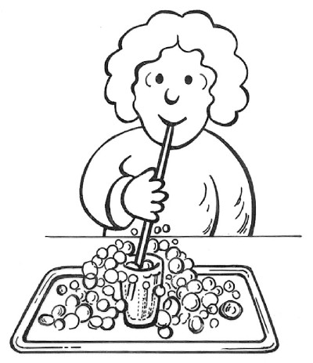

1. I will put \_\_\_\_\_\_\_\_\_\_\_\_\_ drops of \_\_\_\_\_\_\_\_ soap in a bowl of COLD water.
2. Then I will take a 1 deep breath and blow through a straw into the soapy water.
3. I will count how many bubbles that soap made.
4. I will write this in my table and draw a picture of what it looked like.
5. I will put \_\_\_\_\_\_\_\_\_\_\_\_\_ drops of \_\_\_\_\_\_\_soap in a bowl of HOT water.
6. I will count how many bubbles that soap made.
7. I will write this in my table and draw a picture of what it looked like.

MCHH00863_0000[1]Investigating Soap – Making Predictions

I have decided to test how many bubbles are made with different temperatures of water.

Circle the temperature you **predict** will make the **most** number of bubbles:

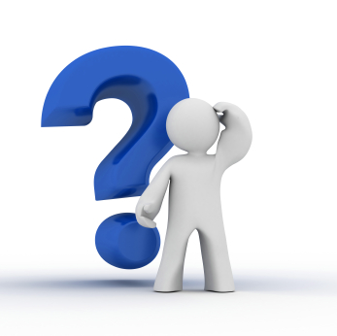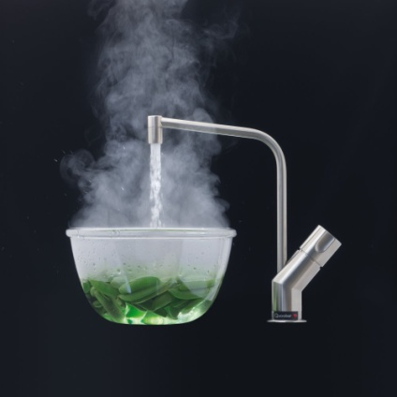 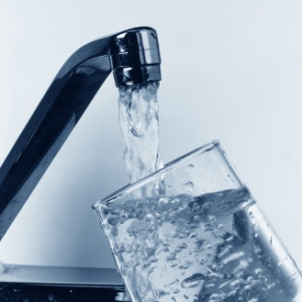

HOT

COLD

I predict that \_\_\_\_\_\_\_\_\_\_\_\_\_\_\_\_\_\_\_\_\_\_\_\_\_\_\_\_\_\_\_\_\_\_\_\_\_\_\_\_\_\_\_\_\_\_\_\_\_\_\_\_\_\_\_\_\_\_\_\_\_\_\_\_\_\_\_\_\_\_\_\_\_\_\_\_\_\_\_\_\_\_\_\_\_\_\_\_\_

\_\_\_\_\_\_\_\_\_\_\_\_\_\_\_\_\_\_\_\_\_\_\_\_\_\_\_\_\_\_\_\_\_\_\_\_\_\_\_\_\_\_\_\_\_\_\_\_\_\_\_\_\_\_\_\_\_\_\_\_\_\_\_\_\_\_\_\_\_\_\_\_\_\_\_\_\_\_\_\_\_\_\_\_\_\_\_\_\_\_\_\_\_\_\_\_\_\_\_\_

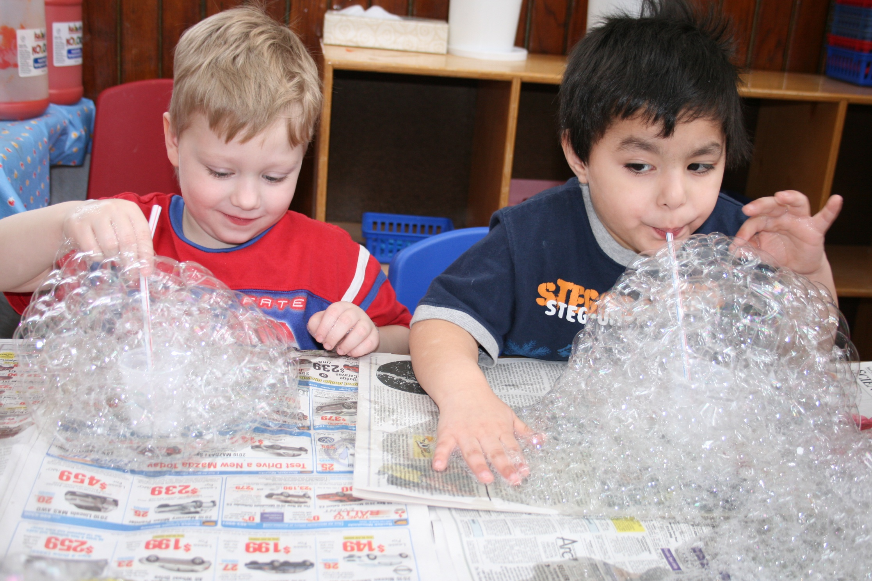

MCHH00863_0000[1]Investigating Soap – My results (PL)

I have decided to compare how many bubbles different temperatures of water make. **Draw a picture of your results here:**

|  |  |  |
| --- | --- | --- |
| Water 1- Here is a picture of the cold water bubbles:  http://www.sterner.co.uk/src/tap.JPG  \_\_\_\_\_\_\_\_\_\_\_\_\_\_\_\_\_\_\_\_\_\_\_\_\_\_\_\_\_\_\_\_\_\_\_\_ |  | Water 2- Here is a picture of the hot water bubbles:  http://www.markpascua.com/wp-content/qooker-instant-boiling-water-tap-9.jpg  \_\_\_\_\_\_\_\_\_\_\_\_\_\_\_\_\_\_\_\_\_\_\_\_\_\_\_\_\_\_\_\_\_\_ |

MCHH00863_0000[1] Investigating Soap – My results (EL)

|  |  |
| --- | --- |
| Water temperature | Number of Bubbles |
| http://www.sterner.co.uk/src/tap.JPG  COLD  \_\_\_\_\_\_\_\_\_\_\_\_\_\_\_\_   °C |  |
| http://www.markpascua.com/wp-content/qooker-instant-boiling-water-tap-9.jpg  HOT  \_\_\_\_\_\_\_\_\_\_\_\_\_\_\_\_   °C |  |

MCHH00863_0000[1]Investigating Soap – My Conclusion

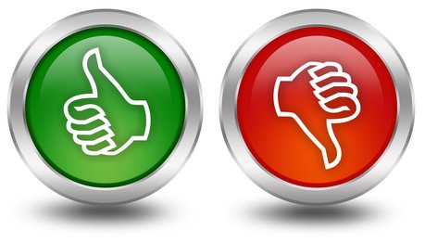

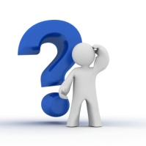Was your prediction right?! Go back and check!

The water temperature that made the **most** bubbles was:

HOT

COLD

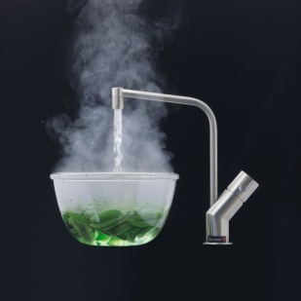

What temperature water would you use to wash the dishes? Why?

I would wash the dishes with \_\_\_\_\_\_\_\_\_\_\_\_\_\_\_\_\_\_\_\_\_\_\_\_\_\_\_ water because \_\_\_\_\_\_\_\_\_\_\_\_\_\_\_\_\_\_\_\_\_\_\_\_\_\_\_\_\_\_\_\_\_\_\_

\_\_\_\_\_\_\_\_\_\_\_\_\_\_\_\_\_\_\_\_\_\_\_\_\_\_\_\_\_\_\_\_\_\_\_\_\_\_\_\_\_\_\_\_\_\_\_\_\_\_\_\_\_\_\_\_\_\_\_\_\_\_\_\_\_\_\_\_\_\_\_\_\_\_\_\_\_\_\_\_\_\_\_\_\_\_\_\_\_\_\_\_\_\_\_\_.

**Extension task:** Repeat the experiment two more times and take an AVERAGE of your results. This is more RELIABLE because you are making sure it wasn’t just a one-off.