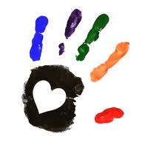

Fire Spreads
Let children use an eyedropper to drop water on a paper towel. Watch how the water spot gets bigger even though more water is not added. Fire is like that, it spreads over an area.

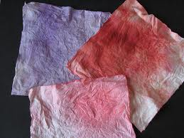

Fish Tank –
Fill a large plastic soft drink bottle about one quarter full with water. Add a few drops of blue food coloring and a drop (wee little drop!) of liquid detergent. Pour in a small amount of clean sand or aquarium gravel. Blow up two small balloons, release most of the air, then tie the ends closed. (We used orange balloons and the "fish" were goldfish!) Push the balloons into the bottle and screw the cap on tightly. When you have finished, you will have a fish tank with two bobbing "fish" inside. Let the children take turns holding the bottle sideways and rocking it
back and forth to
watch the fish "swim"
in the blue water.

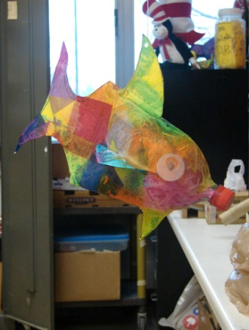

Make a permanent rainbow

- Put water in a small dish and place the black paper in until it is submerged in at least an inch of water.
- Add a single drop of nail varnish
- Slowly lift paper from the water and vola a permanent rainbow

Black paper
Water
Dish
Clear nail varnish

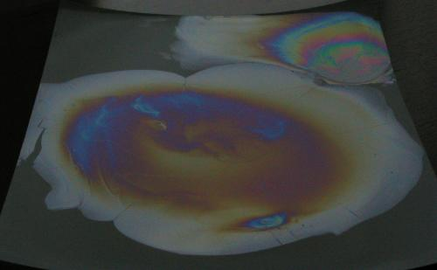

Floating paperclip
- bowl of water
- paper towels
- paper clips
- drop a paperclip in the water and watch it sink
- now add a small piece of paper towel ( a little bigger than the paperclip)
- add the paperclip to the paper towel ( it should float whilst the paper sinks)

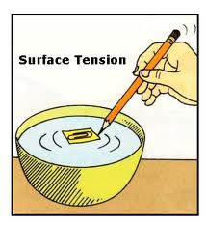

Coloured milk

- Pour enough milk to cover the bottom of a small dish
- Use the eye droppers to drop in small amounts of food colouring to the milk
- Add a drop of dish washing liquid to the milk
- Watch it move
. 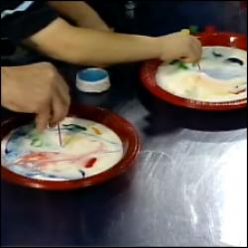
Food colouring
Eye droppers
Washing up liquid
Milk
dish

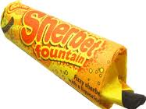
Making sherbet

- Add icing sugar, citric acid, bicarbonate soda and a small dash of jelly crystals to a small dish.( alternatively can make own bags)
- Mix well
- Use a straw to eat.

2 tbs icing sugar
1 tbs citric acid
½ tsp bicarbonate soda
Jelly crystals for flavouring
straw

Shark pepper experiment

Get a bowl of water and add pepper to it. Put a drop of soap of dish washing liquid on your finger then put finger in the water. Watch the pepper move. Add sugar to the water to see the pepper come back together.

Black pepper water
Dish washing liquid sugar

Egg in a bottle
- a milk bottle
- a hard boiled egg
- a small piece of paper
- a lighter or matches

Light a piece of paper and carefully place it in the bottle. Then quickly pop the egg back in the neck of the bottle. The egg will be sucked into the bottle and remain fully intact.

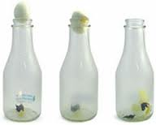

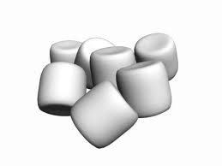

Squishy Play
Marshmallows
Melt in microwave, very sticky.
Add washing up liquid t o make
slimy and bubbly
Mashed Potato
Instant, allow children to mix with
Water, add food colouring.

Bubble Squish
• Pour bath foam on table add a
yogurt pot of water and mix with
hands. Continue as above.
•also could use no tears
shampoo if there is a risk of
children rubbing eyes.

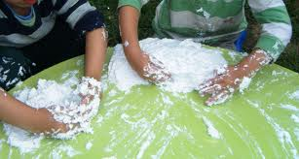

Clean Mud
1 bar ‘Dove’ soap
1 roll toilet paper
½ gallon of water
1. In a large tub layer up toilet
roll.
2. Grate soap and sprinkle over
paper.
3. Add warm water.
4. Leave over night .
5. Use to make models.
Great dough that is very
Smooth and soft. Hardens
quickly and paints well.

Instant Snow
Diaper
water
first cut open a new diaper and remove the cotton wool.
Put the wool in a bowl and add water. The polymer inside the diaper is super absorbent and turns into a snow like substance.
Diaper
water

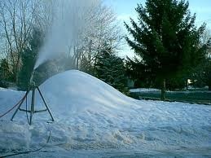

Reference:
Sensory activites from http://www.tes.co.uk/teaching-resource/Sensory-Play-Activities-Ideas-6008165/
Science experiments: http://stepbystepcc.com/science.html
Other useful sites:
http://www.surfnetkids.com/science_experiments.htm
http://www.firstschoolyears.com/science/index.htm
http://www.bigeyedowl.co.uk/science/
http://pbskids.org/zoom/activities/sci/floatingpaperclips.html

