Covid19 social story - school is opening

Version 1

Version 2

Version 3

Covid19 social story - school is opening

Version 1

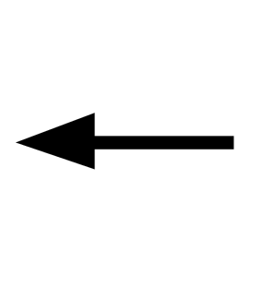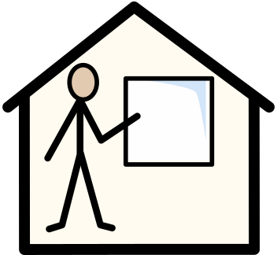

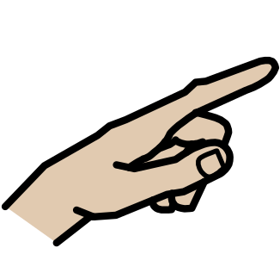
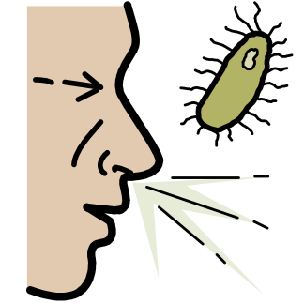
My school has been closed because of Coronavirus.

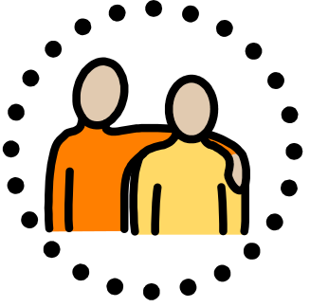
It’s safe to go back to school.

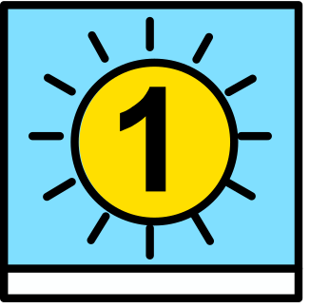
The first day that I will go back to school is (fill in as appropriate).

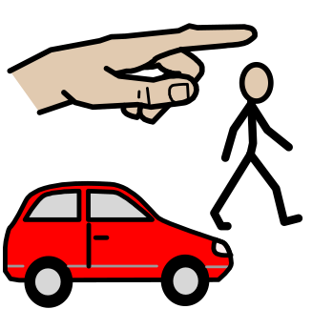
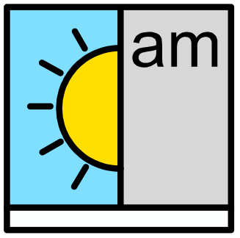
I will travel to school in the morning.

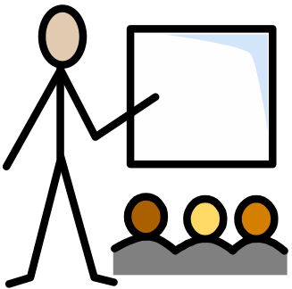
I will have my normal lessons.

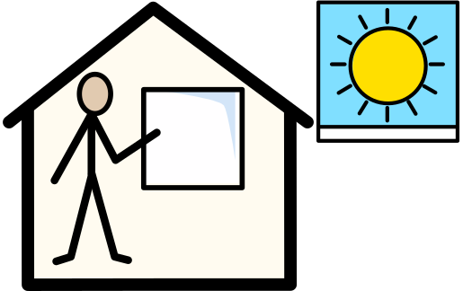
I will travel home at the end of the school day.

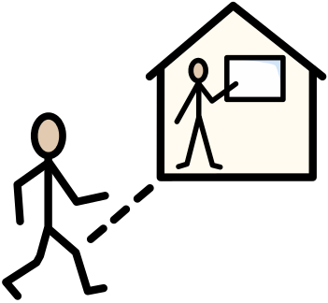
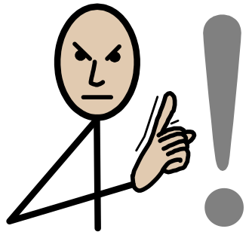
Going to school is important.

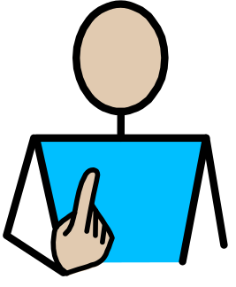
Going to school is good for me.

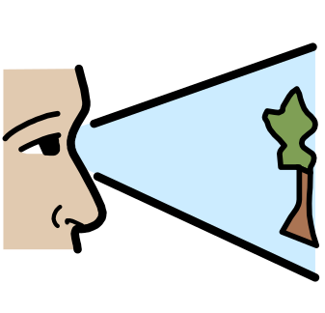
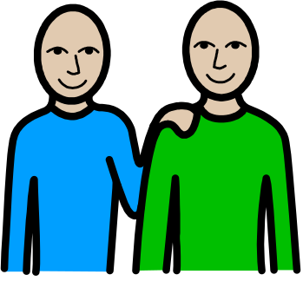
It is good that I can go back to school and see my friends

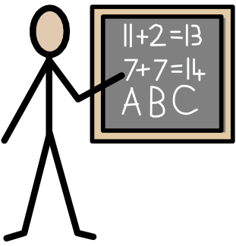
and teachers.

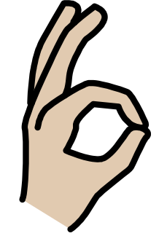
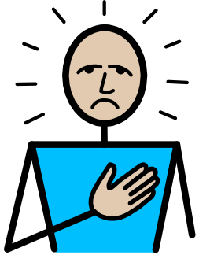
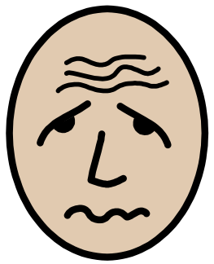
It is ok to feel sad or worried about going back to school.

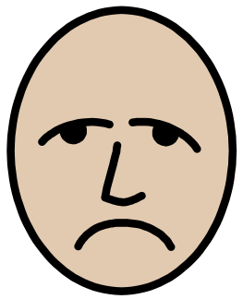
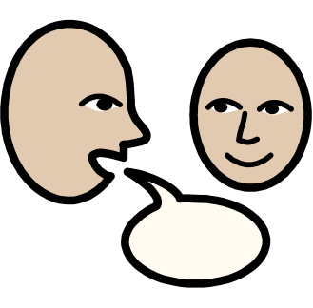
If I am sad or worried about going back to school, I can talk to

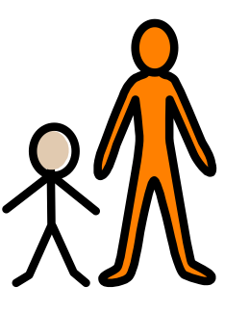
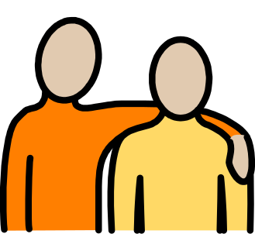
an adult who looks after me.

It is safe to go back to school.

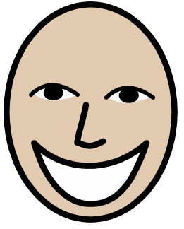
I can be happy about going back to school.

Covid19 social story - school is opening

Version 2

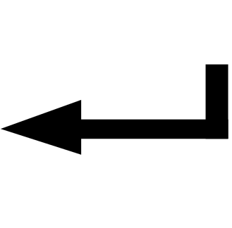

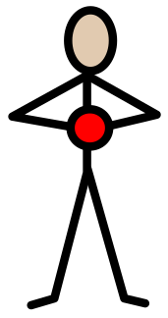
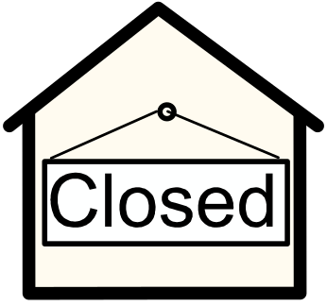
My school has been closed because of Coronavirus.

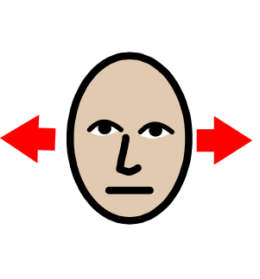
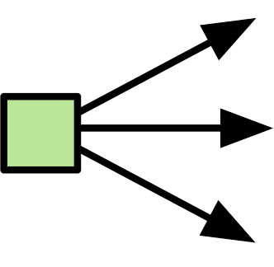
Coronavirus is not spreading as fast as it was.

It’s now safe to go back to school.

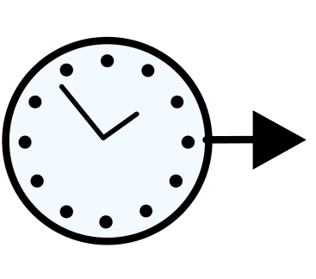
When I go back to school I will get to see my friends.

When I go back to school I will get to see my teachers.

The first day that I will go back to school is (fill in as

appropriate).

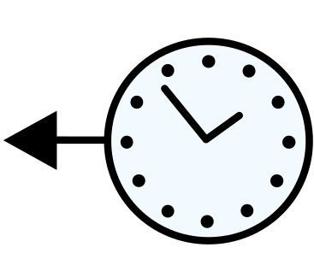
It has been very different while my school has been closed.

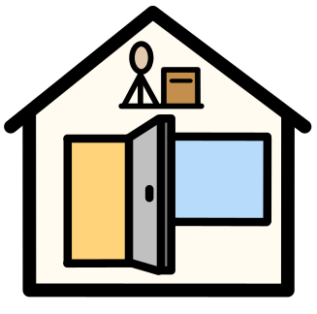
Now that my school is going to open, it will be back to normal.

I will travel to school in the morning.

I will have my normal lessons.

I will travel home at the end of the school day.

Going to school is important.

Going to school is good for me.

It is good that I can go back to school and see my friends.

It is safe to go to school.

I can be happy about going to school.

If I am sad or worried about going to school I can talk to an

adult.

Covid19 social story - school is opening

Version 3

My school has been closed because of Coronavirus.

Coronavirus is not spreading as fast as it was.

It’s now safe to go back to school.

When I go back to school I will get to see my friends.

When I go back to school I will get to see my teachers.

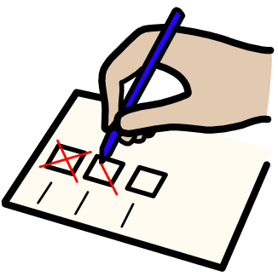
The first day that I will go back to school is (fill in as

appropriate).

It has been very different while my school has been closed.

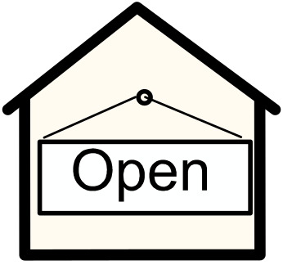
Now that my school is going to open it will be back to

normal.

I will travel to school in the morning.

I will have my normal lessons.

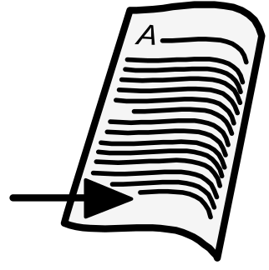
I will travel home at the end of the school day.

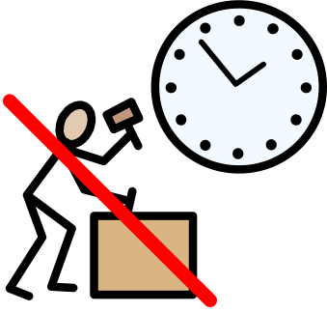
While school was closed I have had more free time.

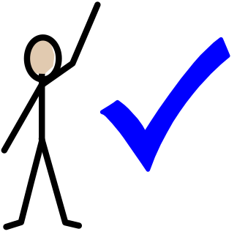
It can be fun to have more free time.

Going to school is important.

Going to school is good for me.

It is good that I can go back to school and see my friends.

It is safe to go back to school.

I can be happy about going back to school.

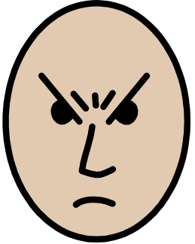
If I am sad, angry or worried about going back to school I can

talk to an adult.

