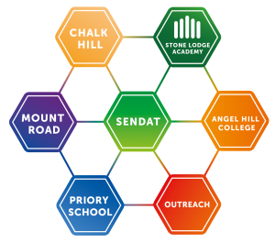

**SENDAT OUTREACH WEEKLY NEWSLETTER: EDITION 8**

Welcome! We will be sharing a weekly newsletter containing ideas and links to support teachers and families of pupils with complex SEND during the Covid-19 crisis.

You do not have to be on caseload to access these materials, and a member of the team will be happy to speak with you if you would like further advice or information

<https://infolink.suffolk.gov.uk/kb5/suffolk/infolink/advice.page?id=9-4-gMINCZ8>

**Sensory Learning**

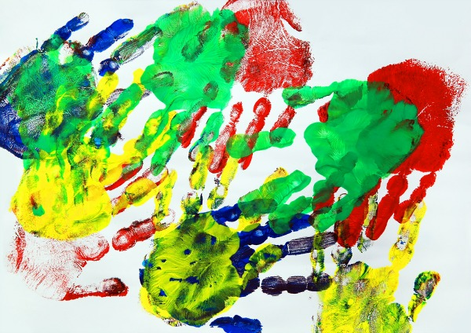

Students who have significant special needs will benefit from experiencing a range of sensory activities. Learning for these pupils should take into consideration their interests, their concentration length and involve their senses.

Involving the senses (seeing / listening / tasting / touching / smelling) will hold pupil interest and engage those who experience difficulties with independent learning.

Sensory play creates hands-on-fun and learning for pupils as they explore and discover through their senses the world around them.

SENDAT have produced a booklet ‘Sensory Learning’ and a folder of ideas to supplement the booklet that may be useful. The folder can be accessed through the SENDAT Outreach useful resources page

<https://sendat.academy/outreach/useful-resources/>

Here are some links from the booklet which provide ideas for sensory activities in school and at home.

Try to make half term week feel different from school weeks, even if you aren’t able to go beyond your home.

Keep to a structure. Limit screen time

Stay in touch with family and friends; write postcards, letters or arrange a video call

Try to eat regularly and healthily; set yourself a challenge. How many colours of the rainbow can you eat today? Make sure you include 5 fruits and vegetables

Learn a useful skill while you are not in a rush: putting shoes on, Self care/ toilet routine, dressing, making a bed, peeling a banana, making a drink

Go for longer cycle rides or walks, make and take a picnic somewhere special

Have a movie night: make tickets, make popcorn and make a night of it.

Play games together as a family; screens off and game time scheduled in. For fairness let everyone take a turn to choose and have fun!

**Fun and educational activities to try**

Sensory Stories are simple narratives with items that can be held to support the pupil interacting with the plot and characters. For example, The Very Hungry Caterpillar would have a “story bag” containing a small caterpillar, items of food, a butterfly, a plastic leaf, a bag of dried leaves, and a small ping pong ball to represent the egg. You can make these from your own resources or look at websites such as <https://www.twinkl.co.uk/resources/literacy/story-resources/story-sack-resource-packs>

Signing - There are some lovely signed stories and songs to use at home and in the classroom <https://www.youtube.com/user/SingingHandsUK>

Playdough words - make some sight word cards, read each word and stand in a pressed flat ball of playdough. Using playdough letter stampers, match letters to the sight word and read. Also use to create name and words of interest

Hook A Duck – Incorporate maths with water play. Retrieve a numbered duck from a water tray. Use for number recognition, ordering numbers, adding two numbers together

Number Hunt- Create a sensory bin using play sand, coloured rice, and any other natural or messy play resource you would like to add. Then bury your numbered shells for a treasure hunt. You could also hide letters or words.

.

Go to the beach! Paddling pool, sand pits and making ice creams. Pop some ice cream into a small cup, and set up shop, buying ice creams from the ‘van’

Have a competition who can make the largest tower from sand/ sticks/ scrap paper and recycling materials, Lego…

Get out the paint brushes and paint with water (floors, walls, anything outdoors); large letters or key words depending on your child’s development. Great for motor skills and letter formation

Go fishing! Using paperclips and magnets, make a simple fishing game focusing on ‘catching’ certain letters, numbers, shapes or pictures

Have a tidy up. Children enjoy helping to sort. Toys can be sorted into type, costumes into themes, socks into pairs! Adapt for your child’s age, interest and development: you may have a tidier house afterwards: bonus!

[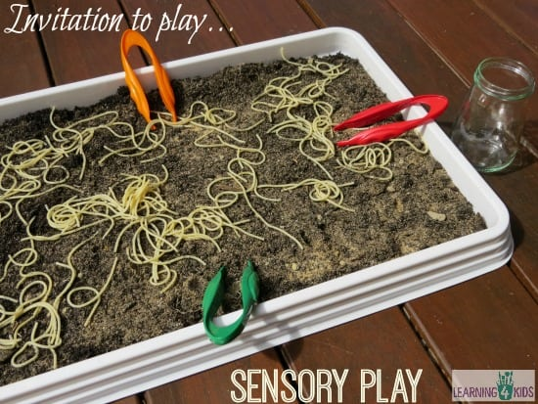](https://www.learning4kids.net/wp-content/uploads/2015/01/Invitation-to-play-spaghetti-worms-in-dirt.jpg)[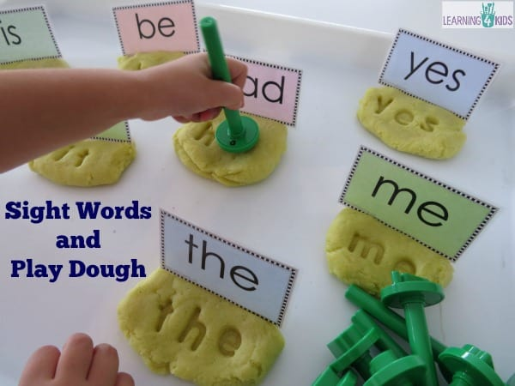](https://www.learning4kids.net/wp-content/uploads/2016/02/Hands-on-fun-with-sight-words-literacy-centres-or-work-station-sight-word-activity.jpg)



<https://sendat.academy/outreach/useful-resources/>

Please look at our website for further resources and contact details. Have fun!

[**https://theimaginationtree.com/sensory-writing-in-fairy-dust-literacy-activity**](https://theimaginationtree.com/sensory-writing-in-fairy-dust-literacy-activity)ideas for sand play to help fine motor control

[**https://www.learning4kids.net/2016/05/02/printable-measuring-length-learning-centre-mat**](https://www.learning4kids.net/2016/05/02/printable-measuring-length-learning-centre-mats/)ideas with equipment readily available

[**https://childhood101.com/sensory-play-idea**](https://childhood101.com/sensory-play-ideas/)divided into activities for touch, sight, smell, sound taste and often with a youtube clip to show you what to do

[https://www.thechaosandtheclutter.com/archives/huge-list-outdoor-sensory-f](https://www.thechaosandtheclutter.com/archives/huge-list-outdoor-sensory-fun) A variety of outdoor activities with clear instructions and pictures.

[**https://kidssteamlab.com/sensory-ar**](https://kidssteamlab.com/sensory-art/) Art activities related to the senses

[**https://www.youtube.com/watch?v=Cih4U17ph**](https://www.youtube.com/watch?v=Cih4U17ph8A)sensory crafts for children

[**https://www.bbc.co.uk/teach/bring-the-noise/SEND-telling-story-music/z7psxyc/**](https://www.bbc.co.uk/teach/bring-the-noise/SEND-telling-story-music/z7psxyc/) SEND : Telling a story with music and sensory exploration

Putting Movement into Maths – write numbers on the outside of a large ball. (These could be whole numbers, fractions, or decimals.) pass the ball around. Each time someone catches, they have to do a maths operation with the two numbers their hands land on.

Bubbles – a super sensory science activity. Can you make smelly, scented, slimy bubble mixes using different dish soap? Which size or shape wand works best? Count the bubbles from each wand.

Ice – many pupils like playing with ice and it’s great to use outside when it’s hot. You can freeze items in ice such as letters, numbers, small toys and see how long it takes to retrieve item.

Foil Painting – lay a long strip of foil on the floor outside or on a table and start painting. Children may rub their hands across the foil with the paint you may want to have a bowl of water ready for handwashing

Digging for spaghetti worms in dirt – fill a container or tray with damp sand / soil. Place spaghetti worms just under the surface or they will break if buried deep. Use hands or tweezers to dig out worm. Count the worms, measure the different lengths