

**SENDAT OUTREACH WEEKLY NEWSLETTER: EDITION**

Welcome! We will be sharing a weekly newsletter containing ideas and links to support teachers and families of pupils with complex SEND during the Covid-19 crisis.

You do not have to be on caseload to access these materials, and a member of the team will be happy to speak with you if you would like further advice or information

**Handwriting**

We know that **s**ome children find it really difficult to write clearly and quickly enough to keep up with school work, despite lots of practise and support. This can cause problems with academic achievement as well as self-esteem and confidence.

**Preparation**

A good position at the table will help your child to be stable, and be able to concentrate and use their hands most effectively.



* Feet should be flat on the floor with hips and knees at about 90º.
* Using a box under their feet will help if the table or chair are too high.
* Encourage your child to sit up straight with their bottom right on the chair rather than perching on the edge.
* A slanted work surface can help (e.g. a wide A4 lever arch folder

**Holding the pencil**

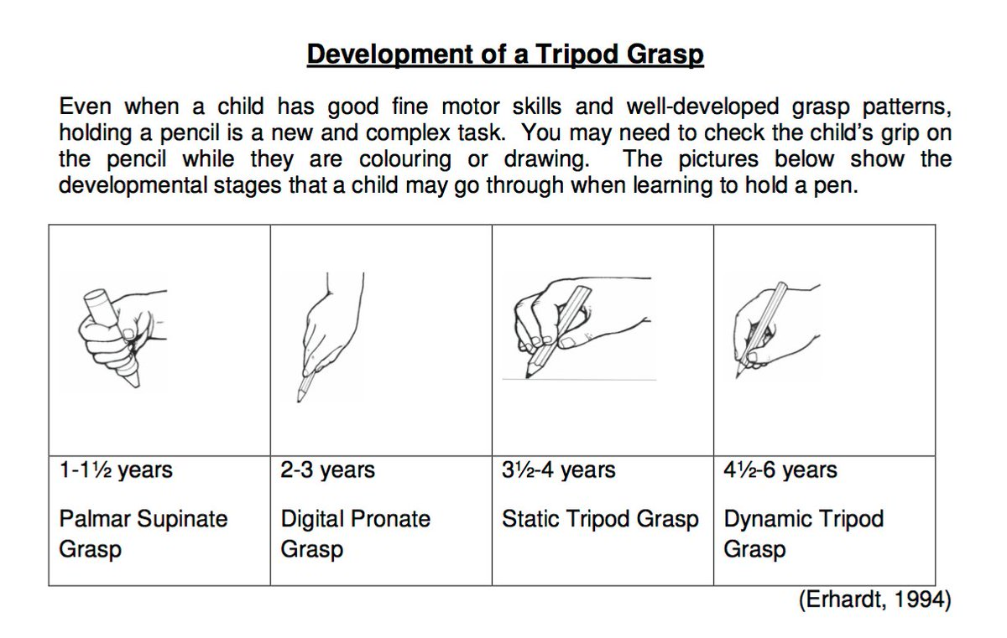

* + - * Lots of children struggle to hold a pencil in a way that helps with handwriting
* The most functional pencil grasp is a tripod (3 finger) grasp as shown in the picture. This allows for the best control when trying to create small accurate letter shapes
* However if your child is writing clearly you probably don’t need to worry however they hold their pencil. Also if they are beyond KS2 trying to change a habit can be really difficult
* Using a chunky shaped pen or pencil, and gel pens can help reduce handwriting strain for children who suffer from aching hands when writing, or find it hard to put enough pressure on the pencil to write clearly

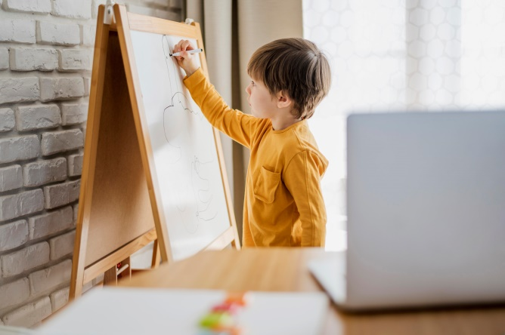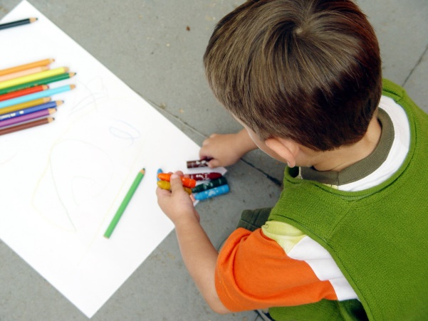

**Using IT to write**

* Whilst it is important to develop handwriting skills, this should not become a barrier to learning. For children who find writing for longer periods challenging, or struggle to create writing that others can read in a legible way using a computer or tablet might help ensure they are able to get their ideas down
* Learning to type is a really useful skill children can practise at home. To use a computer to write, play educational games or even search on the internet it helps to be able to type confidently and quickly.
* If you can type without looking at the keyboard you can focus on the task instead of getting distracted by looking for the letters.
* Lots of typing practise helps create muscle memory so that you can type without having to look at the keyboard and your fingers. It.s a bit like walking without having to look at your feet to know where they are and what they are doing>
* There are lots of free websites that help children learn to find letters on the keyboard and type
  + <https://www.typingclub.com/>
  + <https://toybox.tools.bbc.co.uk/activities/id/activity-dance-mat-typing>
  + <https://www.ratatype.com/>
* The manufacturers of the Clicker word processing software used in lots of our schools are making the Clicker@home licence free during the school closures. There is also lots of useful advice for parents and carers about how to use the software to support struggling writers, and free activities to download for children to use while writing and learning. <https://www.cricksoft.com/uk/clicker/clicker-at-home>

**Handwriting Practice:**

Lots of practise (at least 3 times a week) helps improve pencil control and handwriting.

**Ideas to try at home**

* Draw a pathway with two bold lines and some space between. Encourage your child to draw a line along the pathway without touching the sides. Start with wide, straight pathways and then make them narrower and include curves and angles to make it more tricky.
* Colouring inside bold lines.
* Miss the obstacle – The child draws a line to get from one side of the paper/chalkboard/sand tray to the other without touching any obstacles e.g. toy cars in a sand tray, or dots on a piece of paper.
* dot to dot puzzles & mazes
* Tracing or Stencils.
* Try using lots of different materials to practise writing letter shapes:
* A sponge dipped in paint, wet sponge on chalkboard
* Painting on walls/patio with a wet brush
* Finger paint
* Chalk/crayon -Use 2-3cm piece of chalk/crayon to help encourage the three finger tripod grasp. The child cannot spread their fingers along the chalk or use a fisted grasp as the chalk is too small.
* Felt-tips/ Scented pens
* Pens that light up when you write
* Vibrating pen
* Air drawing/sky writing- the child uses their arm to draw the letter in the air
* Squeezy bottle of water on the pavement or path
* Scarf, streamer or long piece of ribbon, waved in the air to form the letter shapes
  + Try making letter patterns keeping forearms and hand relaxed. Vary the size of the patterns

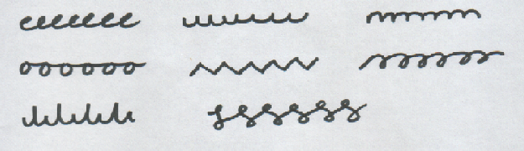

**Websites with useful ideas and worksheets**

* https://www.twinkl.co.uk/resource/t-l-52341-handwriting-activity-sheets.
* https://www.education.com/worksheets/handwriting/.
* https://www.jellyandbean.co.uk/free-resources/
* https://www.sparklebox.co.uk/literacy/writing/

Do you have other favourite books?

Ask your child or go wild, see how much fun you can have with learning and play!