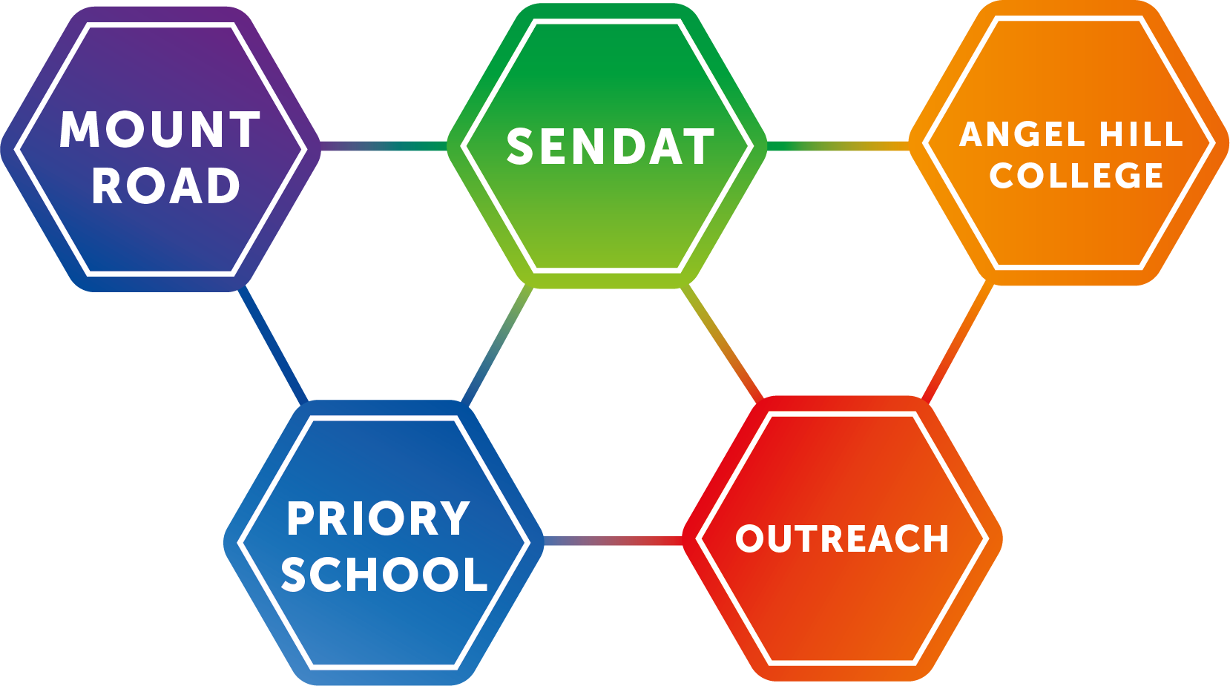
This free guidance is aimed to support teacher assessment of numeracy and has up-to-date advice from the pre-key-stage-standards. The learning goals suggested in this document have been matched to the Pre key stage standards (PKSS) released for September 2018. The PKSS document is to be used for summative assessment at the end of KS1 and 2 with pupils working below national curriculum standards; those pupils were formally described as working within the “P scales”. This grid has been designed to help you identify numeracy learning goals in small steps for these pupils giving you suggestions that inform your assessment of their progress.
SENDAT OUTREACH

Suggested assessment grid linked to the
Pre key stage Standards

Authors: Cathy Hobbs and Vicky Platt
https://assets.publishing.service.gov.uk/government/uploads/system/uploads/attachment_data/file/738696/2018-19_Pre-key_stage_1_-_pupils_working_below_the_national_curriculum_a.._.pdf
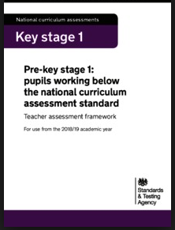
Pupils working in P1-4 were considered to be working below subject specific standards, and need a more specialist curriculum based around their individual needs. The subject specific standards range from 1-4 in Key stage 1 and 2 and match in the following way. This document contains guidance for SENDAT -1 (understanding number) through to standard 4
P4 | SENDAT -1
P5 | Standard 1
P6 | Standard 2
P7 | Standard 3
P8 | Standard 4

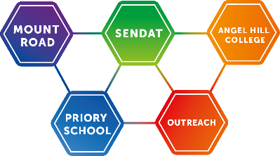
SENDAT Outreach
Maths SENDAT Standard -1 (Previously P4)

Criteria |  | Begun | Mastered
Counting, properties of numbers/number sequences | Show an interest in number activities/counting
Place value and ordering | Copy an adult modelling actions to a simple counting rhyme or chant e.g. nod head, pointing, holding up fingers, vocalisation
 | With support, while singing a familiar song, indicate through sign, speech or gestures the next action/object/number
 | Anticipate the end of familiar sequences
 | Take part in games/activities that give opportunities to score and count
Calculations (Number)
Addition/subtraction | Aware of cause and effect in familiar mathematical activities
 | Repeats action for effect e.g. hitting surface of water to make a splash
 | Explore more than 1 object at a time
 | Responds to “give me some more…..”
 | Says/recognises/responds to “gone or all gone” appropriately
 | Experience losing and having items taken away from them
 | Experience receiving more than 1 item
Solving problems (using and applying maths)
Reasoning about numbers and shapes | Show awareness of changes in shape, position or quantity
Problems involving ‘real life’ money or measures | Be aware of cause and effect in familiar mathematical activities
 | Switch work to gain desired control e.g. choose from 2 switches activate more than 1 switch
 | Anticipate, follow and join in mathematical activities when given a contextual clue
Measures shapes and space | Begin to search for objects that have gone out of sight, hearing or touch, demonstrating the beginning of object permanence
Positions and direction | Demonstrate interest in position and the relationship between objects

Additional comments/observations

NB Mastered means ‘independently’ and on repeated occasions
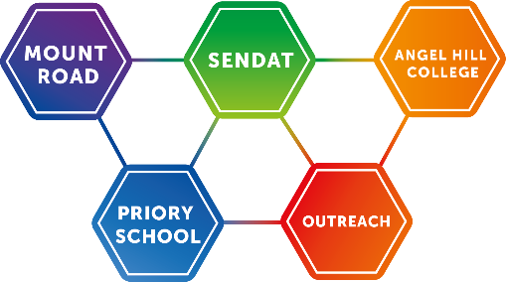
SENDAT Outreach
Maths Pre key stage standard 1 (Previously P5)

Criteria |  | Begun | Mastered
Numbers and number system
Counting, properties of numbers, number sequences | Respond to and join in with familiar rhymes, stories, songs and games e.g. saying, signing or indicating at least 1 of the numbers in a familiar number chart.
 | Indicate one or lots
Place value and ordering | Demonstrate awareness of contrasting quantities by making groups of objects with help e.g. give/identify 1 car/lots of cars. Playing games with cards/dice with nothing/blank/one or two marks e.g. dot/teddy bears
 | Watching finger games
 | Through games and rhymes that involve collecting and accumulation, to begun to appreciate that number names and numerals refer to a sequence of quantity: able to sequence 1 & 2 e.g. 12345, once I caught a fish alive.
 | Use systematic pointing, blinks, or gesture to indicate 1 or lots. Make handprints, footprints etc. Pick up/hold 1 object on request, or lots.
Calculations(number) | Exchange coins for an item
Addition and Subtraction | Indicate 1
 | Making groups of pairs using familiar pairs e.g. shoes/socks
 | Show and name 1 item, assign item in role play (e.g one cup for one teddy)
 | Strike 1 beat on a drum following 1 beat
Solving problems (using and applying mathematics)
Reasoning about numbers and shapes | With support, match objects or pictures
 | Search intentionally for objects in their usual place
Problems involving ‘real life’ money or measures | Begin to sort sets of objects according to a single attribute e.g. colour, size, shape
 | Make sets that have the same number of objects in each
Solve simple problems practically | Match shoes by placing a shoe alongside one that an adult has placed on the carpet
 | Match socks by placing a sock next to one an adult has placed
 | Find matching pairs from a collection of pictures e.g. 2 trees, 2 houses, 2 cars
 | Find functional pairs e.g. cup and saucer, knife and fork, bread and butter, brush and comb
 | Search intentionally for an object in its usual place
 | Go to usual place when told to get items such as their coat
 | Indicate where to go
 | Fit all the balls in a basket
 | Put all the hoops on a hook
 | Put all the large play equipment in the shed
 | Put all the furry toys in a box
 | Can indicate where objects should go
 | Distribute sweets into containers so that there are 2 in each
 | Indicate correct amount in each container
 | Make sets the same

Criteria |  | Begun | Mastered
Solve simple problems practically | Organise items into rows so they can be compared
 | Select/indicate appropriate containers for items of different sizes
 | Carry out events against the clock or time count
 | Experience comparing weights
Measures, shapes and space | Search intentionally for objects in their usual space e.g. round hoops in the PE cupboard. Square mats in the lunch drawer. Cubes in the Numicon box
 | Compare overall size of one object with that of another where there is a marked difference
 | Find big and small objects on request
 | Explore the position of objects e.g. place them inside/outside a hoop, in front of/ behind a line, fit as many as possible in a box, line up train carriages, pour from one container into another, put large round pegs onto a peg board
 | Indicate which of 2 saucepans is big
 | Indicate whether a child’s or an adult’s scarf is long. Indicate which of 2 pieces of string is long/short
 | Share items, giving 1 to each pupil (pencils, brushes etc)
 | Follow instructions to place a small skittle at one end of a mat and a large skittle at the other
 | Use familiar objects e.g. big ball and small ball, big chair and small chair, big plate/small plate
 | Indicate by vocalising, signing, gesture or touch the correct position of an object e.g. milk in the fridge, hat on a child’s head, book on a shelf

Additional comments/observations

NB Mastered means ‘independently’ and on repeated occasions
SENDAT Outreach
Maths Pre Key stage standard 2 (previously P 6)
Criteria |  | Begun | Mastered
Numbers and number system | 1
Counting, properties of numbers & number sequences | Demonstrate an understanding of 1:1 correspondence in a range of contexts e.g. aware that there are too few/too many to complete 1:1 matching. Gives each pupil a pencil. Match cups to saucers reliably. Touches or points to each coat on pegs as an adult touches and counts.
 | Join in with new number rhymes, songs, raps, stories and games with some assistance or encouragement
Join in rote counting up to 5. Use numbers to 5 in familiar activities and games.
Count to 5, though this may involve joining in with the teacher as the teacher counts
 | Say or sign number names or indicate numerals e.g. as 5 favourite things are taken from a bag, in time with the beat of aa drum, cymbal or handclaps
 | Count reliably to 3 and make sets of 3 objects e.g. 3 windows in the classroom, make 3 sounds, drum or move to waltz time
 | Touch 1 item held by an adult, touch 2 ears, touch 3 buttons, touch 3 items as an adult counts
 | Count toys, pictures of objects or 1p coins
 | Count e.g. 3 cutlery pieces- knife, fork, spoon, 3 items of clothing- hat, coat, scarf
 | Identify whether there are 1,2,3 objects in a group of objects
Place value and ordering | Demonstrate an understanding of more/less
 | Say, sign or indicate that more counters, hoop, cups are required
 | In response to an adult, indicate which hoop has fewer balls in it
 | Can identify which set has ‘more’ (sweets, crisps) using sets with large differences
 | Demonstrate an understanding of the concept of more (e.g. indicating that more cups are required so that all the children have a cup)
Calculations(number)
Addition Subtraction | Demonstrate their understanding of 1:1 correspondence in a range of contexts
Solving problems – using and applying maths
Reasoning about numbers and shapes | Copy a simple pattern or sequences e.g. beating a 1 or 2 beat pattern on a drum or triangle
 | Copy a pattern of repeated movements e.g. stand up sit down
 | Copy next to adult model, a pattern of coloured beakers/beads using 2 colours/shapes/sizes
 | Make a chain of dominoes matching dot patterns for numbers 1 to 3
 | Copy a pattern using real life materials e.g. apples, oranges and bananas
Problems involving ‘real life’, money or measures | Sorts objects with a high degree of success e.g. cutlery, PE equipment, edible/non-edible, by a given criteria, by own criteria. Put paper money in a wallet and coins in a purse
 | Sort objects and materials according to given criteria
 | Begin to identify when an object is different and does not belong to given categories
 | Use 1p coins
 | Hand coin to shopkeeper in role play and receive item in return
 | Hand 2 coins over receive 2 items
 | Count how many coins are needed to buy 4 items
 | Give a 1 coin for 1 item
Measures, shapes and space | Show awareness of vocabulary e.g. more/less in practical situations e.g. which piles contain more cubes, which jug has more juice in it?
 | Compare overall size of one object with that of another where the difference is not great e.g. put nesting cubes, Russian dolls in size order then fit into each other
 | Gives large/big/small items on request
 | Sort and compare big and small objects on request
 | Manipulate 3D shapes e.g. build a tower of 3/4/5 bricks. Roll a tube in a race. Explore how w tube fits into a circular hole. Posting box, inset puzzles
 | Search for objects not found in their usual place, demonstrating understanding of object permanence
 | Search for familiar objects which are out of sight e.g. break time beakers, rulers, counting equipment
 | Show understanding of words, signs, symbols that describe positions
 | Respond to a request to put or find e.g. find a shoe inside a bag, put bag behind a chair
 | Sort and compare big and small objects on request

Additional Comments/observations

NB Mastered means ‘independently’ and on repeated occasions

SENDAT Outreach Level
Maths Pre key stage standard 3 (previously P7)

Criteria |  | Begun | Mastered
Numbers and number system | 0-5
Counting and properties of number and number sequences | Step on floor number track in order from 1-10 as number names are said or signed by adults or other pupils
 | Join in with rote counting to 10
 | Join in by pointing to appropriate numbers on an individual number track, as numbers are said or signed
 | Count up to 10 objects reliably in a variety of everyday situations
 | Begin to recognise numerals from 1-5 and to understand that each represents a constant number or amount
 | Match numerals to the dot pattern that comes up on a dice
 | Count out the correct number of objects (1-5) into a box which has a relief numeral
 | Use orderly tally marks and associate them with spoken number names to 5
 | Create dot patterns with stickers and associate them with the numerals
 | Collect the correct number of items up to 5
Begin to recognise differences in quantity | Using sets of objects with large differences, can identify which has ‘more’ and which has ‘less’
 | Identify the larger and smaller group of 2 sets of objects
Calculations (number) | Respond appropriately to key vocabulary and questions e.g. How many?
 | Respond to instructions e.g. put 2 pencils in the box and add 3 more
Beginning to recognise differences in quantity | In practical situations, respond to ‘add one’ or ‘take one’
Solving problems (using and applying maths)
Reasoning about numbers and shapes | Collect items into sorting drawers and indicate to an adult what to label the box
Problems including ‘real life’, money, measures | Identify when an object is different and does not belong in a given familiar category e.g. put the red books on the shelf and the blue books in a cupboard. Put 3 pencils in the pot and the rest in the tray. Put all the silver coins in the purse.
 | Respond appropriately to key vocabulary e.g. How many? And questions
 | Complete a range of classification activities using a given criteria e.g. sort a pile of coins by colour, size, shape, by the name. Sort all the wellies that are size 4
Measures, shapes and space | Use familiar words to compare sizes and quantities e.g. bigger, heavier, longer, taller
 | Start to pick out named shapes from a collection
 | Begin to respond to ‘forwards’ and ‘backwards’
 | Use familiar words to describe position
 | Can say where an object is in relation to another

Additional Comments/observations

NB Mastered means ‘independently’ and on repeated occasions
SENDAT Outreach
Maths Pre key stage standard 4 (previously P8)

criteria |  | Begun | Mastered
Numbers and the number system | 0-9
Counting properties of numbers and number sequences | Join in with rote counting to beyond 10 e.g. song like 1,2,3,4 Mary at the kitchen door… By singing, signing or indicating correct number names
 | Say, sign number names or indicate numbers in order from 1-10
 | Continue the rote count onwards from a given number e.g. playing a game and adding to a collection of counters/objects
 | Continue to say, sign or indicate counting aloud together up to 5, then 10, when an adult starts by counting the first 2 numbers
 | Continue to say, sign or indicate count up to 5, then 10, with adult prompting on the number line 3,4,5…
 | Continue to say, sign or indicate the count when an adult starts using a familiar counting rhyme/chant/song
 | Begin to count up to 10 objects e.g. chairs around a table, beakers on a tray, friends on a bus
 | Count up to 10 saying the number names in the correct order, matching the correct number name to each object in the count and appreciate that the last number counted represents the total size of the group
 | Estimate a small number and check by counting
 | Using numbers that can be checked by counting, guess then count the number e.g. children in the group, cups needed for break
Place value and ordering | Begin to recognise numerals from 1-9 and relate them to sets of objects e.g. count objects in a box and find correct numeral
 | Match the numerals 0-9 to groups of objects e.g. using number cards to indicate there are 5 apples in a picture of apples
 | Compare 2 given numbers to objects saying which is more and which is less e.g. given a stick of 2 cubes and a stick of 8 indicate which stick has less (fewer)
 | Begin to use ordinal numbers (first, second, third) when describing position of people/objects e.g. indicate which person is first in the line, which lesson is second in the day
 | Follow instructions in order e.g. first put your hand up, second touch your nose, third touch your nose
Calculations(number) | Recall number bonds to and within 5
In practical situations add one to/take one away from a set | Using objects placed on, or people standing on a number track, can add one more to 3 people in line and say, sign or indicate how many people remain in the line. Can take one person away and say, sign or indicate the number left
 | Can add/take away 1 from a number of objects
 | Use real life objects (e.g. apples/crayons) to add and subtract 1 from a group of objects and say how many are now present
 | Can use number lines to 10 to find the number before/after/one more/one less
 | Demonstrate an understanding that the number of objects remains the same when they are rearranged providing nothing has been added or taken away
Solving problems (using/applying maths) | Shows understanding of +, -, =
 | Can swap + and – and numbers or sets of objects to show same total (inverse relationship)
Recognise, describe and recreate simple repeating patterns and sequences | Recognise that there are 2 colours used in a simple potato print pattern e.g. red, green, red, green and continue the pattern  Continue and create a pattern using real life materials (e.g. apples, oranges and bananas)
 | Watch an adult make a simple sequence of actions and objects, then repeat them
Problems involving real life, money or measures | Begin to use their developing mathematical understanding of counting to solve simple problems encountered in play, games or other work e.g. use tokens or marks to tally events or scoring in games.
 | Draw examples of counting from the school environment
 | Use ordinal numbers to describe positions and turns e.g. first turn left, second walk forward, third turn right
 | Begin to make simple estimates, such as how many cubes fit into a box, how many sweets fit in a hand, how many cubes fit in a jar
 | Use counting skills to tell how many more items needed e.g. cakes for everyone to have one
 | Can move sets of objects but understands the total remains the same (commutative law)
Measures, shapes and space | Compare directly 2 lengths or heights, where the difference is marked and can indicate the ‘long one’ or the ‘tall one’
 | Find an object that is longer than, heavier than, shorter than etc.
 | Show awareness of time using names of the days of the week, significant times in the day, e.g. mealtimes, bedtime. Recite the days of the week, knowing each day has a name. Discuss what they did before lunch will do after. Sequence 4 pictures of daily events
 | Begin to use mathematical vocabulary such as ‘straight’ ‘circle’ ‘larger’ to describe the shape and size of solids and flat shapes e.g. pick out all the triangles from a set of 2D shapes or cubes from a set of 3D shapes. Find all the lids which are circles/not circles. Say, sign or indicate which of 2 squares/circles are larger
 | Pick out all the squares that are bigger than a given one
 | Use an answer board / communication device to respond to math questions
 | Create and name shapes in simple models, pictures or patterns
 | Stamp shapes in damp sand and describe them
 | Stamp out shapes using dough and pastry cutters, then talk about the shapes
 | Use a set of flat shapes to make pictures/patterns, name the shapes used
Additional Comments/observations

NB Mastered means ‘independently’ and on repeated occasions

