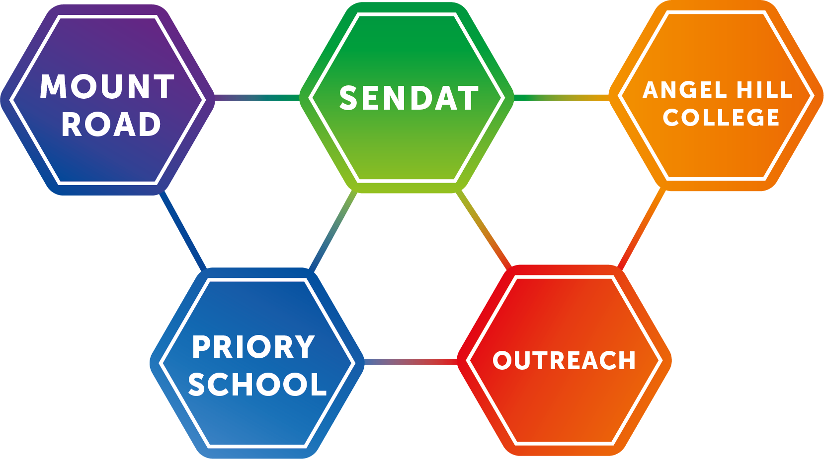
Guidance for planning, teaching and assessing numeracy skills in pupils working below National Curriculum Standards.

This free guidance is a combination of resources from Willow Dene School, and up-to-date advice from the pre-key-stage-standards. The learning goals and activities suggested in this document have been matched to the Pre key stage standards (PKSS) released for September 2018. The PKSS document is to be used for summative assessment at the end of KS1 and 2 with pupils working below national curriculum standards; those pupils were formally described as working within the “P scales”. This booklet has been designed to help teaching staff plan numeracy activities for these pupils; enabling them to practise skills and giving you suggestions that inform your assessment of their progress.
https://assets.publishing.service.gov.uk/government/uploads/system/uploads/attachment_data/file/738696/2018-19_Pre-key_stage_1_-_pupils_working_below_the_national_curriculum_a.._.pdf
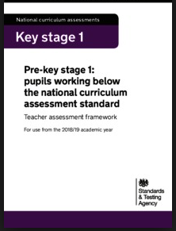
“This scheme in no way attempts to be comprehensive. Rather, it aims to offer some ideas of the different areas of early mathematical development, the way mathematical skills may progress, relevant objectives to support progress and a small range of possible teaching activities to promote the development of these skills which can be used as starting points”. WD
Pupils working in P1-4 are considered to be working below subject specific standards, and need a more specialist curriculum based around their individual needs. The subject specific standards range from 1-4 in Key stage 1 and 2 and match in the following way. This document contains guidance for Standards 1, 2 and 3.
P5 | Standard 1
P6 | Standard 2
P7 | Standard 3
P8 | Standard 4
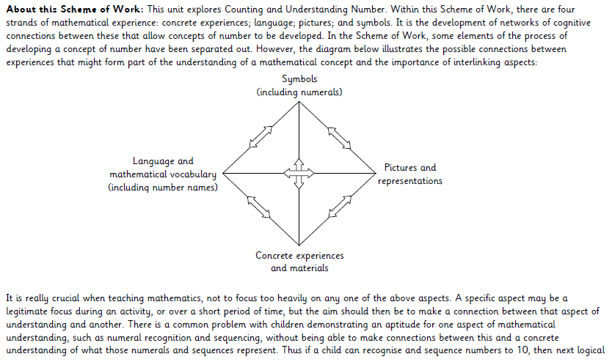

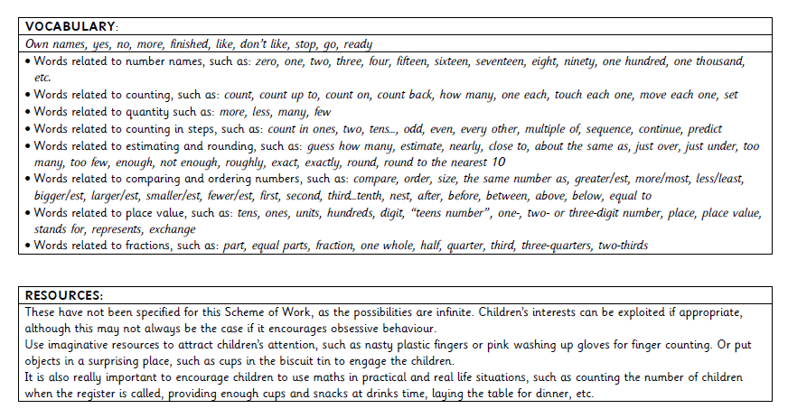
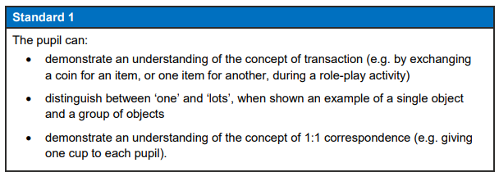
Standard 1

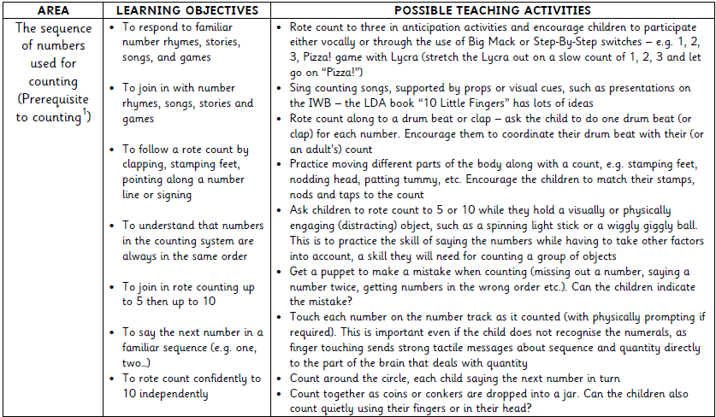

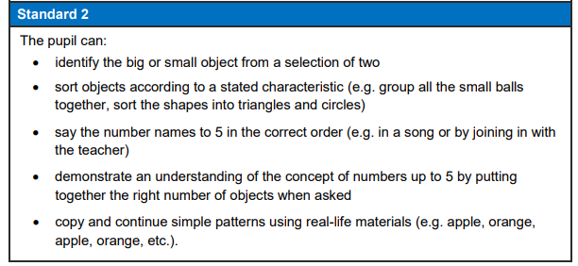
Standard 2

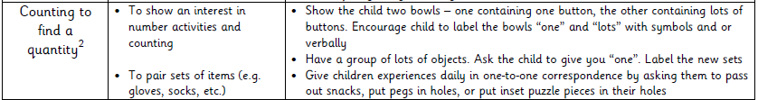
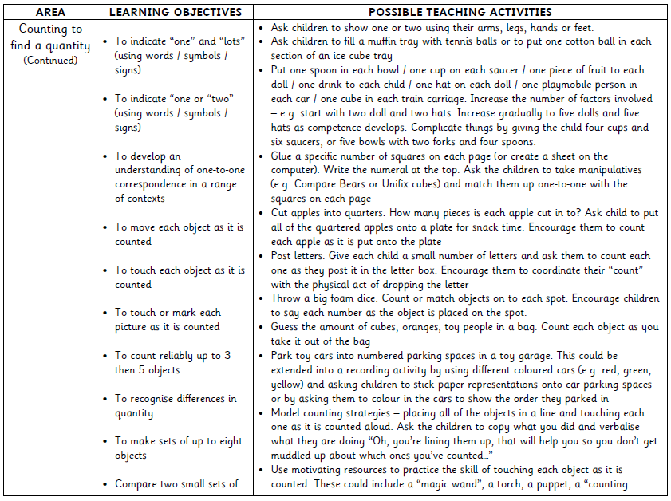
Standard 2
Standard 3
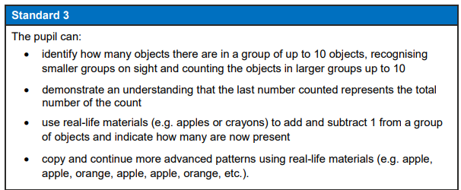
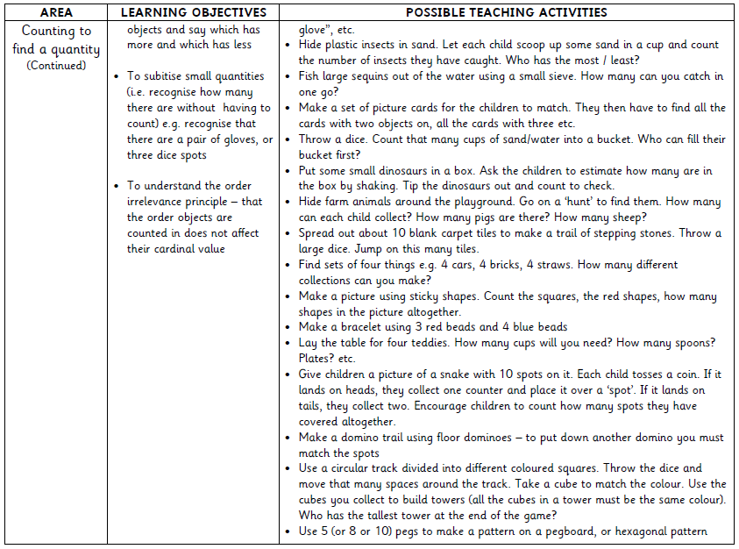
Standard 3
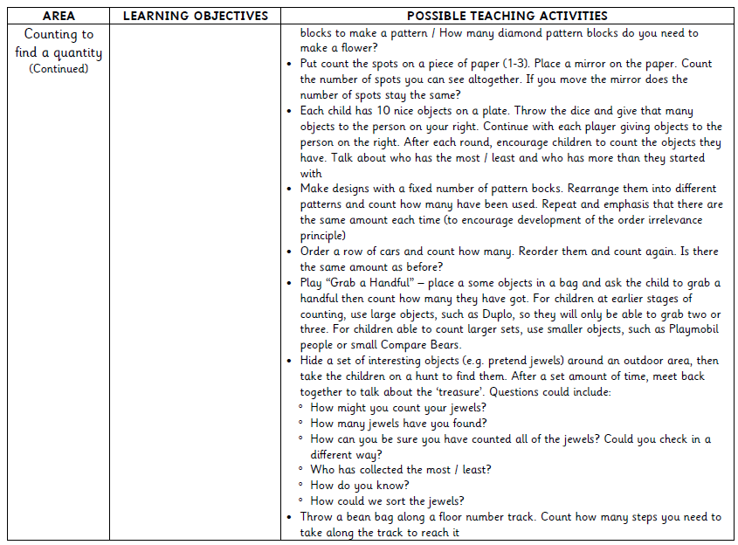
Standard 3
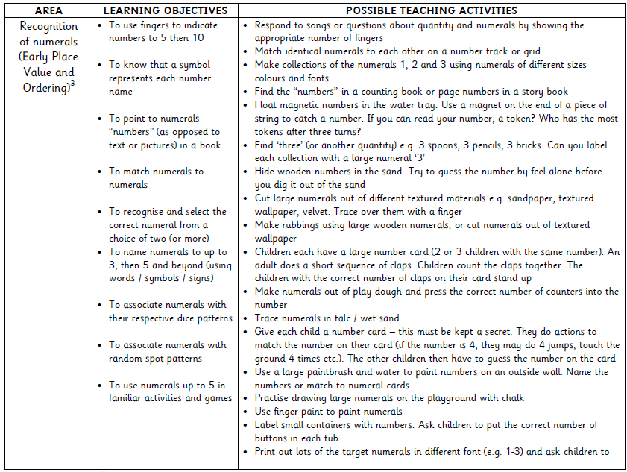
Standard 3
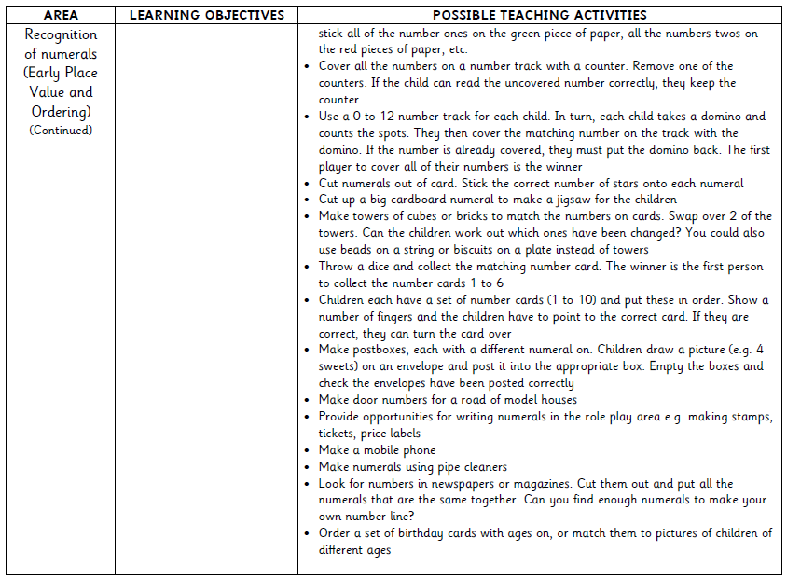
Standard 3
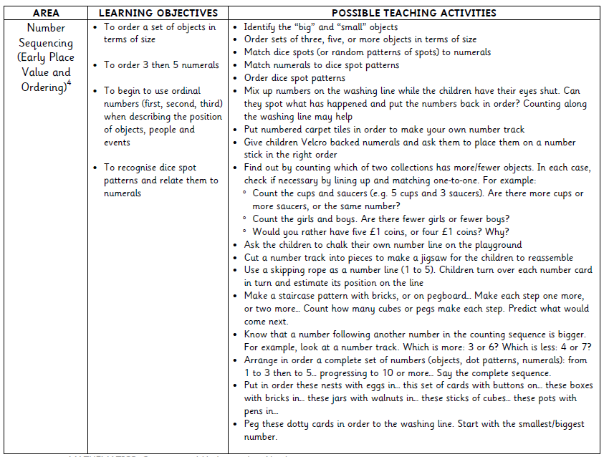
Standard 3
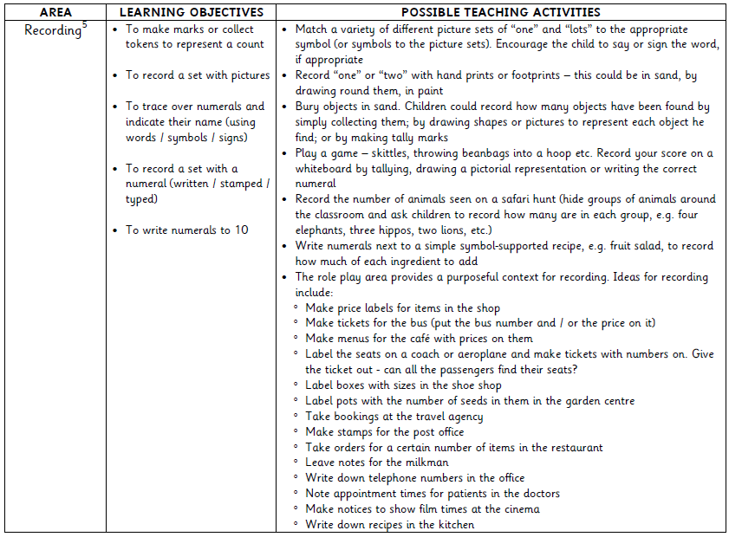
Standard 3
