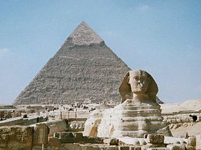
Year 9 Computer Task
Task: to produce an Egyptian Power Point

Create a power point of 6 slides.

For each slide find a picture and type one sentence about it.

Slide 1: The Ancient Egyptians

Slide 2: The pyramids

Slide 3: Egyptians mummies

Slide 4: Egyptian gods

Slide 5: The Pharaoh

Slide 6: The River Nile

Save and print your work

Ancient Egyptians Computer Task 2
Task: Use publisher to create an information sheet about the Egyptians

Find a picture and type one sentence about it.

1: Egyptian slaves

2: Egyptian writing

3: Cats in Ancient Egypt

4: Egyptian charm bracelets

5: The After Life

6: The Animals of the River Nile

Save and print your work

