Name: __________________ Date: _______
Bedsit project

Imagine you have saved £300.
You want to buy things you need to move into a bedsit.
The bedsit already has:
- a bed, mattress and pillows
- a fridge and cooker
- a table and chairs
- a sofa

Task 1
Make a list below of things you might need:

Task 2
Research the prices of items on websites or use Argos catalogues.
Cut out or save the pictures for a poster or leaflet.
Make a list below.
Item | Price | Shop

Task 3

Decide on what you really need and put on page 4-5.

Round to the nearest pound to make the numbers easier.

Work out the total.

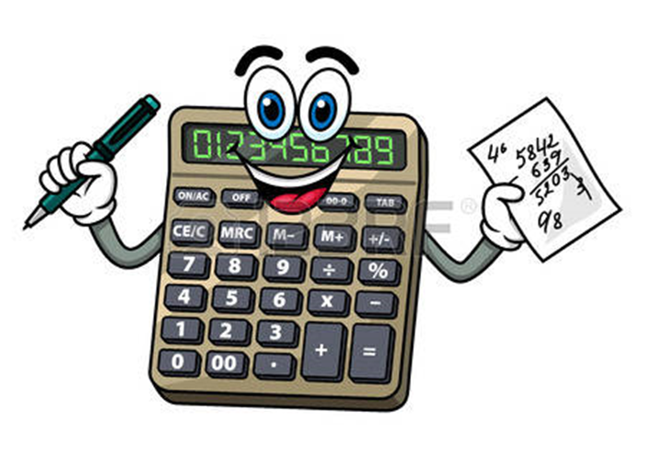

If you have money left, write in other things you would like.

Make your final list below:
Item | Price | Round to nearest £ | Shop | Item no

TOTAL PRICE = ________

What did you think were you best bargains?

Was anything more expensive than you thought it would be?

Task 4

Now make a poster or a leaflet with pictures of your choices and some advice for someone who has to budget for moving into a bedsit.

Task 5
Write a list of expenses you would have when you live away from home:

e.g. electricity bill

