Life and Living Skills: Home Management

My cleaning diary:

 | 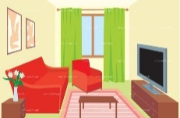  Living room: Dusting, polishing, hoovering | 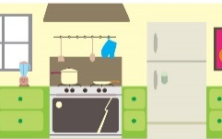  Kitchen:  Taps, surfaces, floor | 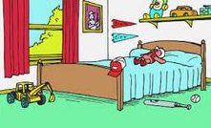  Bedroom:  Dusting, polishing, hoovering | Bedroom:  Changing bed linen | Bathroom:  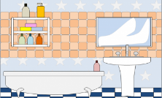  Sink, bath, shower, floor | Toilet | 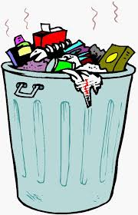  Empty bins
Monday
Tuesday
Wednesday
Thursday
Friday
Saturday
Sunday

