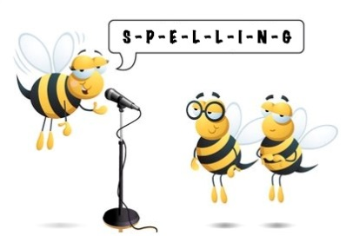
Entry 1 Spelling Practise
Week Beginning : 16/03/2020

Spellings | Monday | Tuesday | Wednesday | Thursday | Friday
oa
boat
coat
road
loaf
toast
soap
groan
float

