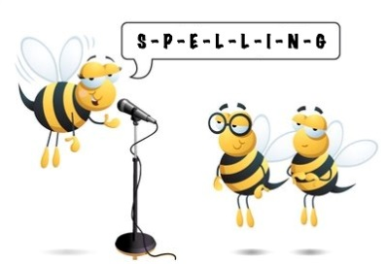
Entry 1 Spelling Practise
Week Beginning : 23/03/2020

Spellings | Monday | Tuesday | Wednesday | Thursday | Friday
ou
cloud
loud
round
found
shout
out
house
mouse

