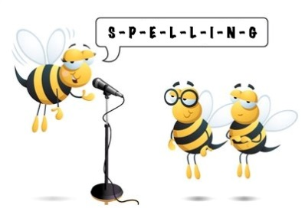
Entry 2 Spelling Practise
Week Beginning 23/03/2020

Spellings | Monday | Tuesday | Wednesday | Thursday | Friday
ir
girl
fir tree
stir
sir
dirty
thirty
thirsty
circus

