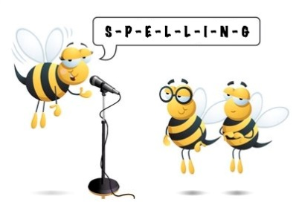
Entry 2 Spelling Practise
Week Beginning 16/03/2020

Spellings | Monday | Tuesday | Wednesday | Thursday | Friday
oa
road
soap
soak
soaking
coal
goal
goat
moan
oak
roast
toast

