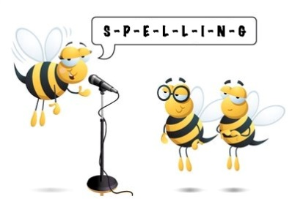
Entry 2 Spelling Practise
Week Beginning 30/03/2020

Spellings | Monday | Tuesday | Wednesday | Thursday | Friday
house
mouth
sound
round
shout
shouted
aloud
about
count
ground
pound
outside

