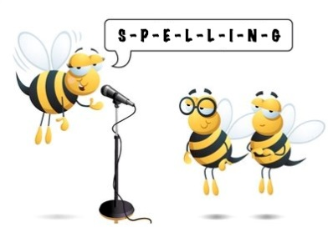
Entry 3 Spelling Practise
Week Beginning – 16/03/2020

Spellings | Monday | Tuesday | Wednesday | Thursday | Friday
ai
again
against
bargain
pain
painful
painless
main
complain
complaint
explain
remain
remained
contain
mountain
 | Monday | Tuesday | Wednesday | Thursday | Friday
first-aid
waist
training
waiting
sail
sailing
snail
fail
failure
rail
trail
afraid

