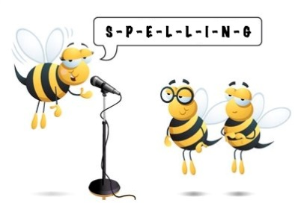
Entry 3 Spelling Practise
Week Beginning – 30/03/2020

Spellings | Monday | Tuesday | Wednesday | Thursday | Friday
ir
thirty
thirteen
third
first
twirl
twirled
circus
circle
circled
circuit
circular
circulate
circumference
circumstances
 | Monday | Tuesday | Wednesday | Thursday | Friday
Firm
firmly
confirm
squirm
squirmed
squirt
squirted
stir
stirred

