First Collage home Learning Challenge
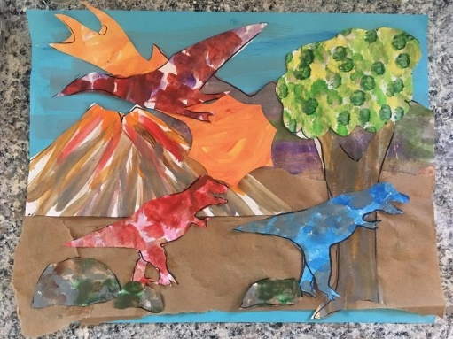
Dinosaurs are a broad and varied group of reptiles. They lived between 243 and 201 million years ago. Fossils tell us about dinosaurs that flew in the air, walked on the land, and swam in the sea. When dinosaurs lived, our Earth probably looked very different in some ways, but similar to the way it looks now in other ways. Try to create a dinosaur landscape with some familiar elements, like mountains, rocks, and clouds. Then add some different elements you think might have been seen a long time ago, like ancient plants or meteors.
- For the background paint half the sheet of paper as sky and other half as ground.

- On blank paper, paint or colour sections using different colours and patterns. Experiment with diagonals, dots, scribbles, and other patterns

- Then, cut out parts of your landscape from the paper you create, and layer them as a collage.
Tip: Wide lines of brown, purple, and green make good “mountains” paper, Swirls of orange, red and yellow make “fire” paper.
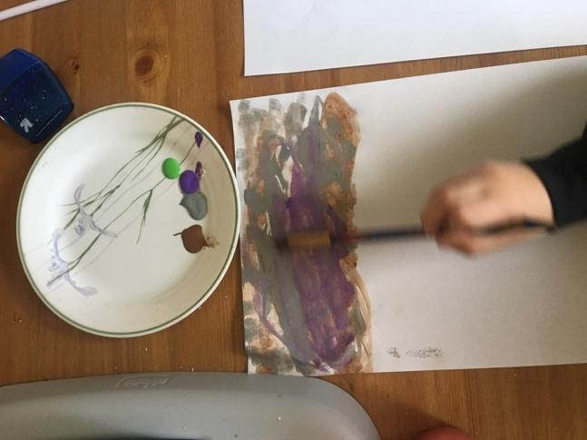
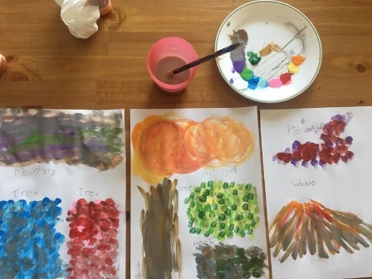

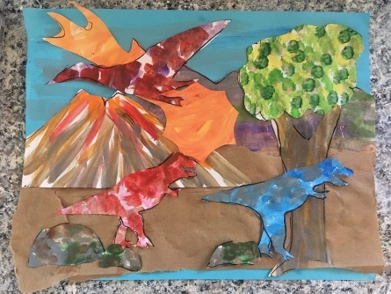

For additional art appreciation, Henri Matisse created collages by painting large pieces of paper and then cutting out fun shapes to arrange as collages. “Icarus” and “The Horse” are great to explore.

