Fractions work
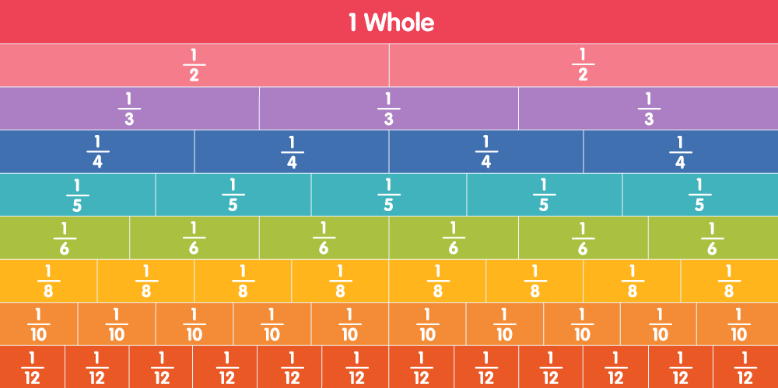
Here you can see some Fraction videos
https://priorysuffolksch.sharepoint.com/:f:/r/sites/PrioryStudentwork/Shared%20Documents/Priory%20Student%20work%20for%20home/Key%20stage%203/3DP%20Mrs%20Paul/maths/Fractions%20activities?csf=1&e=rOtdhW

Purple Mash will have some Fraction work set too https://www.purplemash.com/sch/priory-ip32

Now try Top Marks for Fraction work
https://www.topmarks.co.uk/maths-games/7-11-years/fractions-and-decimals

