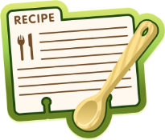
Life and Living Skills: Home Management

Basic safety rules for food preparation: Food storage
Can you organise your fridge?

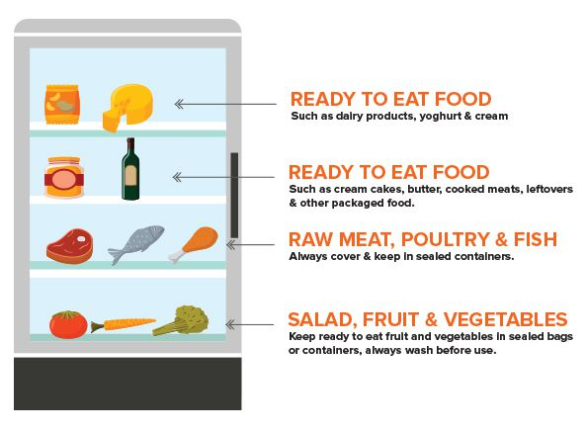

Top and middle shelf
Ready-to-eat foods, such as dairy products, ready meals and packaged foods, leftovers, cooked meats and prepared salads. These should all be covered or kept in sealed containers to prevent contamination. Ready-to-eat foods are stored at the top of the fridge, away from raw foods so that harmful bacteria cannot transfer from the raw food to the cooked food.

Bottom shelf
Raw meat, poultry and fish in sealed containers to stop them touching or dripping onto other foods. Raw meats should always be stored at the bottom of your fridge to prevent cross-contamination. Ensure that each item is wrapped or in a sealed container so that it doesn’t come into contact with other foods.

Salad drawer
Fruit, vegetables and salad vegetables should always be washed before you store them. Make sure that your fruit, vegetables and salad are wrapped in paper or plastic with air holes to keep them protected from any contamination. For salads and herbs, try wrapping them in a damp paper towel before storing to prevent them from drying out and to keep them fresher for longer.

Food Hygiene Tips for Your Fridge
Remember that your fridge should be set at a temperature between 0-5°c so that the rate of food spoilage is slowed and harmful bacteria cannot multiply. At this temperature, your food will be kept safe to eat.
Also remember to keep an eye on use-by dates. Any food that has passed its use-by date should not be eaten as harmful bacteria has had chance to grow and make the food dangerous to health.

