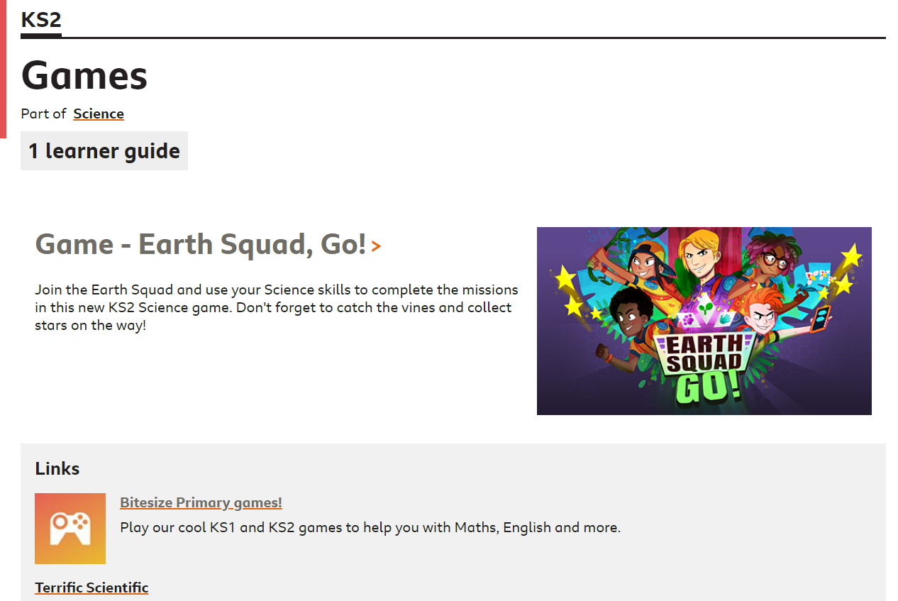
Log on to BBC Bitesize and search for Game - Earth Squad, Go!

