Gardening ideas with Mrs Grant ’green fingers.’
Some terrible play on words from Mr Parkington:
‘Grant the seed.’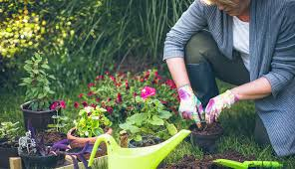
‘Grant force.’
‘From Grant to plant.’
Mrs Grant is our school librarian, but a keen gardener in the Key stage 4.
A message from Mrs Grant:
As it's spring I thought it might be nice for the pupils to have a go at planting some seeds, all you need is a packet of seeds, a bit of compost and a pot (cress can be grown on a piece of damp kitchen paper).
Sunflowers are always a good start. Also if you can, take some photos and we can put up a display when we come back to school. These websites might be helpful.
Best wishes,
Mrs Grant.
https://learn.eartheasy.com/guides/gardening-with-children/
http://www.bbc.co.uk/gardening/gardening_with_children/
https://www.rhs.org.uk/education-learning/gardening-children-schools

