 **Life and Living Skills: Home Management**

Can you help at home?



|  |
| --- |
|  |
|  |
|  |

1. [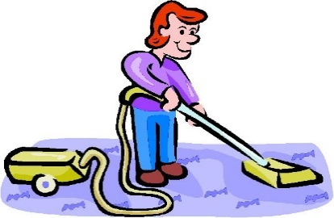](https://www.google.co.uk/url?sa=i&rct=j&q=&esrc=s&source=images&cd=&cad=rja&uact=8&ved=0ahUKEwir0qiFz-TOAhXJzRoKHW7LAQkQjRwIBw&url=https://www.pinterest.com/pin/30328997461320055/&bvm=bv.131286987,d.d2s&psig=AFQjCNGfNslvb9yX2DHbpwd4aB1Gv_Oq2w&ust=1472491105669111)

|  |  |  |  |  |  |  |  |
| --- | --- | --- | --- | --- | --- | --- | --- |
|  |  | |  |  |  |  |  |
|  |  | |  |  |  |  |  |
|  |  |  |  | 1. [Image result for mopping clipart](http://www.google.co.uk/url?sa=i&rct=j&q=&esrc=s&source=images&cd=&cad=rja&uact=8&ved=0ahUKEwjGvLTVz-TOAhVE2RoKHQMQDQIQjRwIBw&url=http://www.clipartpanda.com/categories/populism-clipart&bvm=bv.131286987,d.d2s&psig=AFQjCNHpepBlts5DqNa0lvC5YMHtmELv5w&ust=1472491284412944) |  | 1. [Image result for scrubbing clipart](http://www.google.co.uk/url?sa=i&rct=j&q=&esrc=s&source=images&cd=&cad=rja&uact=8&ved=0ahUKEwjMkpTfzuTOAhXKnRoKHW7lBfUQjRwIBw&url=http://www.123rf.com/photo_35976720_stock-vector-retro-comic-book-style-cartoon-woman-scrubbing-floor.html&bvm=bv.131286987,d.d2s&psig=AFQjCNF1BaaOJOdDOpX9kS1idgKpSoPmag&ust=1472491017975346) | |

Vacuum the carpets Mop the hard floors Scrub any stains

[](http://www.google.co.uk/url?sa=i&rct=j&q=&esrc=s&source=images&cd=&cad=rja&uact=8&ved=0ahUKEwjvpvqP0eTOAhXFPBoKHaBaAXkQjRwIBw&url=http://www.shutterstock.com/s/sweep/search-vectors.html&bvm=bv.131286987,d.d2s&psig=AFQjCNHXxZpFROTeCwq3XfYSJhAoPIMojw&ust=1472491668298999)[](http://www.google.co.uk/url?sa=i&rct=j&q=&esrc=s&source=images&cd=&cad=rja&uact=8&ved=0ahUKEwi--Nz1zeTOAhUMahoKHastBOgQjRwIBw&url=http://classroomclipart.com/clipart-view/Animations/Business/dusting_gif.htm&bvm=bv.131286987,d.d2s&psig=AFQjCNE6HUVTOBLE1msQ7dCO7l1QWws2ag&ust=1472490773971963)[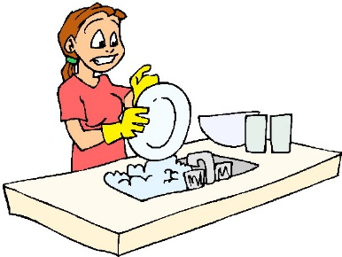](http://www.google.co.uk/url?sa=i&rct=j&q=&esrc=s&source=images&cd=&cad=rja&uact=8&ved=0ahUKEwiv58nwz-TOAhXBuBoKHcHSBxcQjRwIBw&url=http://www.clipartkid.com/wash-up-cliparts/&bvm=bv.131286987,d.d2s&psig=AFQjCNGYJVRvSocBQ2yd4i_XZtIORHAb9A&ust=1472491340328742)

Sweep the hard floors Wash the dishes Dust the cobwebs

[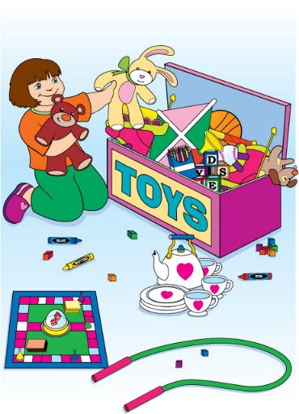](http://www.google.co.uk/url?sa=i&rct=j&q=&esrc=s&source=images&cd=&cad=rja&uact=8&ved=0ahUKEwj5-Za0z-TOAhUHfRoKHcCvA90QjRwIBw&url=http://www.clipartkid.com/clean-up-toys-girl-cliparts/&bvm=bv.131286987,d.d2s&psig=AFQjCNFDdKvix4l6BA1RbBKydVgR4zTfpA&ust=1472491188810219)[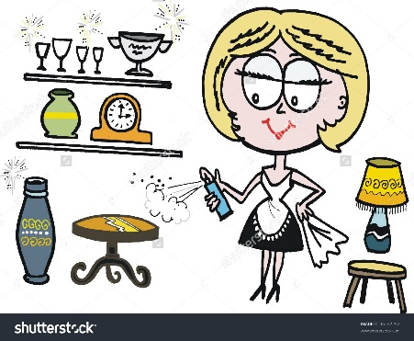](http://www.google.co.uk/url?sa=i&rct=j&q=&esrc=s&source=images&cd=&cad=rja&uact=8&ved=0ahUKEwj0vfKE0uTOAhXHMBoKHRSPCx4QjRwIBw&url=http://www.shutterstock.com/pic-95292292/stock-vector-vector-cartoon-of-woman-cleaning-and-polishing-furniture.html&bvm=bv.131286987,d.d2s&psig=AFQjCNHaPFlX5vxd0IHwU8mk6YMu24PiVQ&ust=1472491892472761)[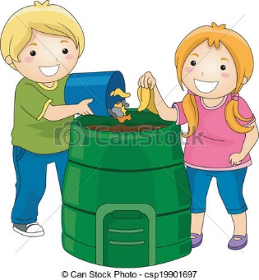](http://www.google.co.uk/url?sa=i&rct=j&q=&esrc=s&source=images&cd=&cad=rja&uact=8&ved=0ahUKEwiw3fDd0OTOAhUBVhoKHTm8DxQQjRwIBw&url=http://www.canstockphoto.com/vector-clipart/compost-bin.html&bvm=bv.131286987,d.d2s&psig=AFQjCNFeKpFv4sgDqUbwTwDhHMHflIfMfQ&ust=1472491574609070)

Tidy away your things Empty the bins Clean the surfaces