Choose any of the art activities below. Keep to bring in later or send in photographs for me to see.
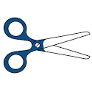
Be careful with scissors or ask an adult to help.
Green = fun for everyone Red = some more effort needed Yellow = Challenging
Paint some pebbles and turn them into colourful creatures. | Make street art on your computer or tablet  https://www.tate.org.uk/kids/games-quizzes/street-art. | With an adult make some playdough and then make a model.  https://theimaginationtree.com/best-ever-no-cook-play-dough-recipe/ | Make a fingerprint  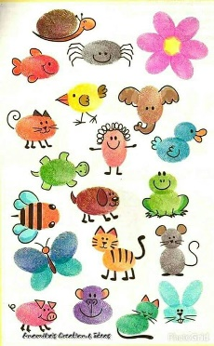  picture | If you have a pebble / shell collection use them to make patterns  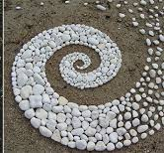
Use your hand to make funky animal drawings  https://www.youtube.com/watch?v=LtvGQ-Izk-8 | Follow the guide “Third Poppies” to make a poppy picture | Follow the guide “First Collage” to make a painted paper collage | Visit the Soul of a Nation exhibition https://www.tate.org.uk/kids/explore/kids-view/kids-think-about-art-and-race  Pause it on your favourite work of art and draw it. | Learn to draw a landscape. Use paint or coloured pencil if you don’t have pastels  https://www.youtube.com/watch?v=_8ipGDh22aY
Practice one line drawing.  https://www.youtube.com/watch?v=0WeMpBlgpuA  Watch first then watch again and follow along. | Art Ninja Dinosaur mask  https://www.bbc.co.uk/cbbc/joinin/art-ninja-dinosaur-mask-make | Art Ninja  Escher tessellation picture  https://www.bbc.co.uk/cbbc/watch/art-ninja-escher-painting?collection=art-ninja-makes | Learn about perspective  Pause the video at each step to follow along.  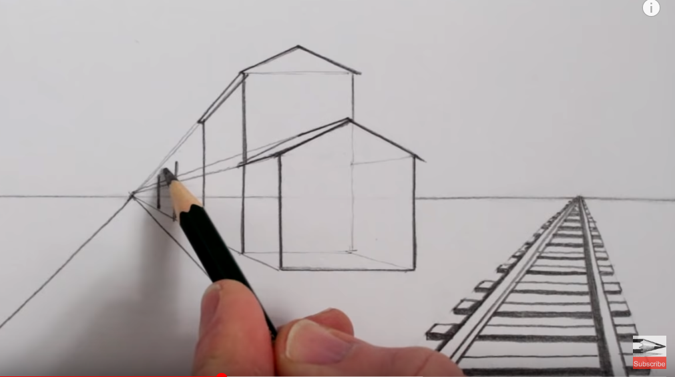  https://www.youtube.com/watch?v=1U7STmL3jrw  A ruler will help  . | Learn to shade to make objects look 3d  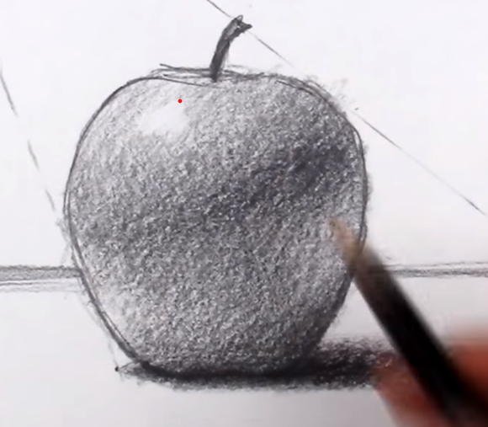  https://www.youtube.com/watch?v=-WR-FyUQc6I

