How to Make Invisible Ink
2/27/20 - By Ally Noel
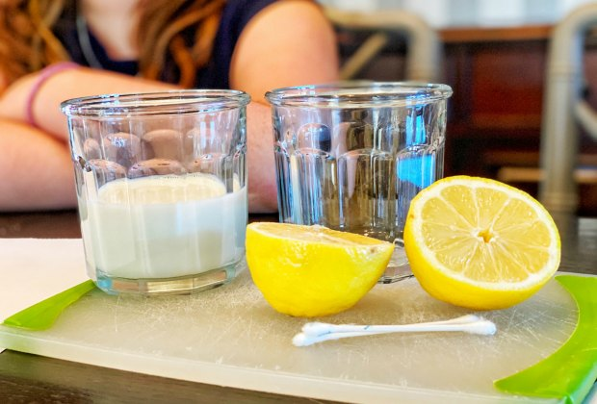
We used milk and lemon juice to create our invisible ink.

Step 1
Gather your ingredients and tools. For this experiment, you need a piece of paper, a cotton swab, a heat source (a lamp or electric stove works), and milk or lemon.
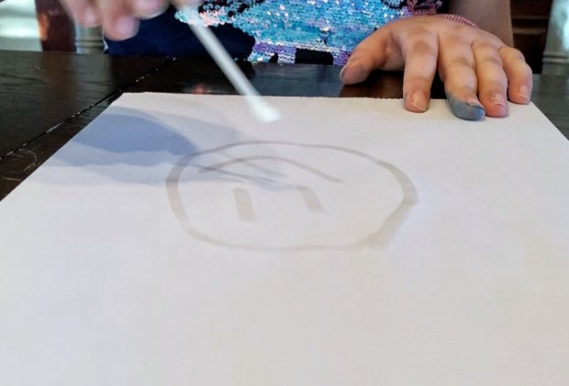
Draw or write your secret message.

Step 2
If you are using lemon juice, squeeze your lemon into a glass. You can mix it with a little bit of water. Dip your cotton swab into the milk or lemon juice and start writing your message. Let your message dry completely.
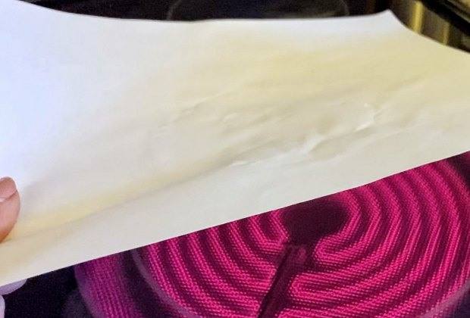
Apply heat to get the secret message to appear.

Step 3
Once dry, an adult should hold the sheet of paper over a heat source. We used an electric stovetop. You can also use a lamplight or blow-dryer.
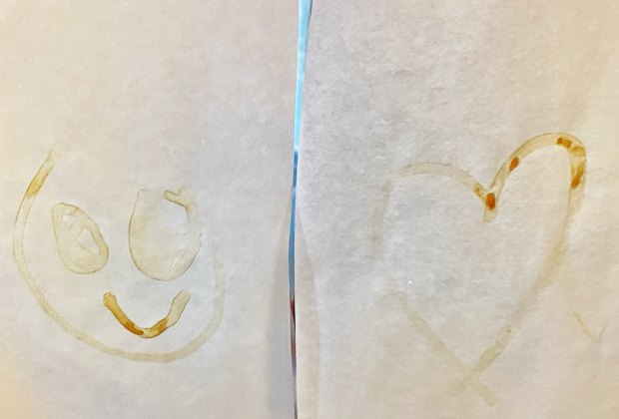
Your messages will appear like magic!

Step 4As the milk or lemon “ink” heats up, it will oxidize and turn brown. You can try this experiment with other substances such as vinegar, honey, or orange juice.

