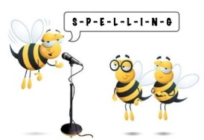
Level 1 Spelling Practise
Week Beginning – 23/03/2020

Spellings | Monday | Tuesday | Wednesday | Thursday | Friday
arctic
argument
architect
bargain
cardigan
cargo
carton
compartment
department
jargon
marmalade
margarine
parliament
regards
remarkable
 | Monday | Tuesday | Wednesday | Thursday | Friday
Startle
starve
awkward
afterwards
apparatus
backward
burglar
coward
custard
forward
orchard
particularly
preparation
regular
separate
separation
reward
towards
energy

