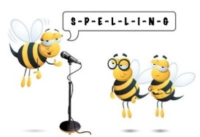
Level 1 Spelling Practise
Week Beginning – 30/03/2020

Spellings | Monday | Tuesday | Wednesday | Thursday | Friday
famous
humorous
jealous
marvellous
nervous
ridiculous
carnivorous
coniferous
porous
vigorous
curious
envious
industrious
mysterious
previous
 | Monday | Tuesday | Wednesday | Thursday | Friday
serious
atrocious
conscious
unconscious
precious
spacious
suspicious
anxious
conscientious
energy

