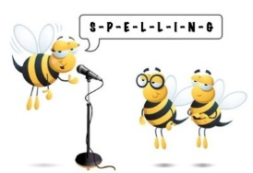
Level 1 Spelling Practise
Week Beginning – 16/03/2020

Spellings | Monday | Tuesday | Wednesday | Thursday | Friday
Soft g
age
damage
image
manage
manageable
unmanageable
manager
message
messenger
postage
rage
rampage
salvage
George
 | Monday | Tuesday | Wednesday | Thursday | Friday
Georgina
geography
generation
generosity
huge
knowledge
knowledgeable
privilege
sergeant
tragedy
vegetable
giant
gigantic
gipsy
imagine
religion
gym
gymnasium
gymnast
energy

