Make a Sundial
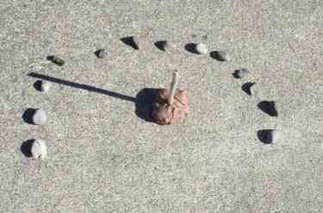
Materials
- stick
- rocks or chalk
- 1 cup of playdough (optional)
- watch or clock
- Find a sunny spot in a lawn or even on a sidewalk.
- Put the stick in the ground. If it is a sidewalk, put the stick in the playdough and use that to hold the stick upright on cement.
- Throughout the day, place a rock, or mark with chalk for each hour indicating where the shadow falls at that time. Depending on your time, you may have to place rocks over a couple of days before your sundial is complete.
Now your sundial is ready to use. When you want to tell the time, just look for the shadow. In the picture above, the stones are used to mark each hour from 7am to 7pm. The picture was taken at 9:15 in the morning.
In the beginning, you may find it hard to be very precise. With a bit of practice, you should be able to tell time to the nearest 15 minutes, and maybe even more closely.
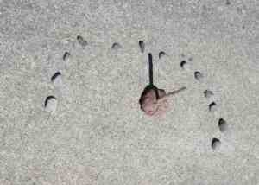 | It's about 12:30 in this picture.
Alternative
- Use chalk and a ruler to draw in the shadow lines, instead of placing rocks on the hour.
You can print out a sundial.

