Naked Eggs
Which came first, the rubber egg or the rubber chicken?
This experiment answers the age-old question, “Which came first, the rubber egg or the rubber chicken?” It’s easy to make a rubber, or “naked,” egg if you understand the chemistry of removing the hard eggshell. What you’re left with is a totally embarrassed, naked egg and a cool piece of science.

EXPERIMENT
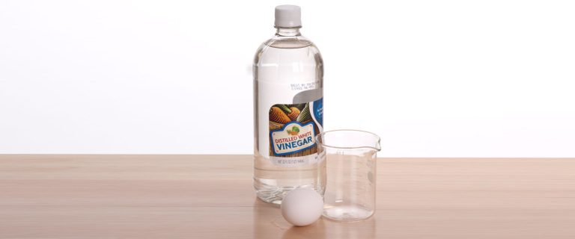

1
Place the egg in a tall glass or jar and cover the egg with vinegar.
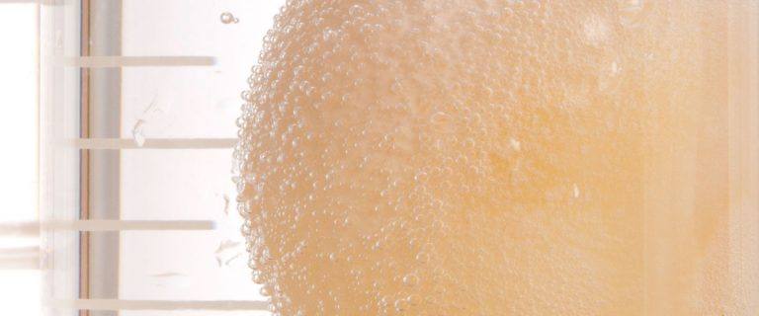

2
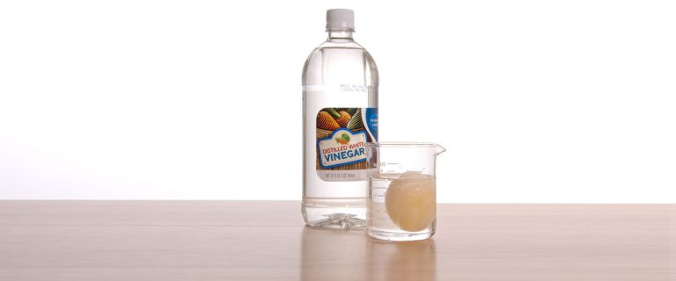
Look closely at the egg. There will likely be tiny bubbles forming on the shell.

3
Leave the egg in the vinegar for a full 24 hours.
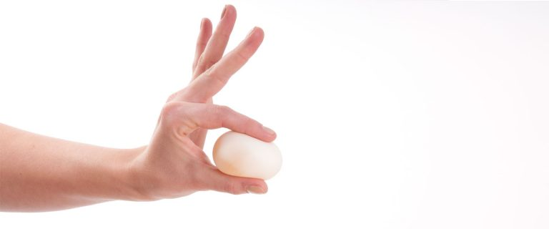

4
Change the vinegar on the second day. Carefully pour the old vinegar down the drain and cover the egg with fresh vinegar. Place the glass with the vinegar and egg in a safe place for a week—that’s right, 7 days! Don’t disturb the egg but pay close attention to the bubbles forming on the surface of the shell (or what’s left of it).

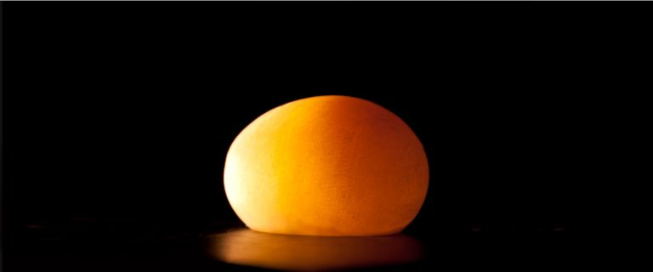

5

One week later, pour off the vinegar and carefully rinse the egg with water. The egg looks translucent because the shell is gone! The only thing that remains is a delicate membrane of the egg surrounding the white and the yolk. You’ve successfully made an egg without a shell. Okay, you didn’t really make the egg (the chicken made the egg), you just stripped away the chemical that gives the shell its strength.

