Note of explanation

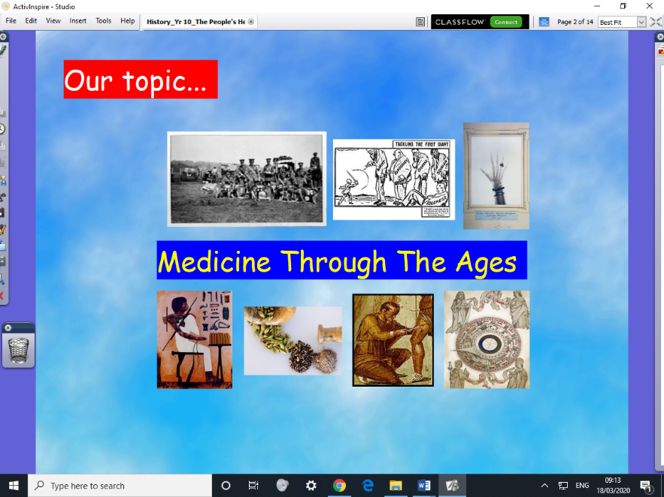
We are a long way through this unit of work:

We have already studied medicine from the ancient civilisations (Egypt, Greece, Rome), also the decline in knowledge in medieval times, followed by improvements in the Renaissance period (15th – 16th centuries).

Our current topic is the improvements made in the 19th century. We have already studied the advances in medicine, such as Germ Theory (Louis Pasteur), vaccinations (Edward Jenner), the discovery that we are made of cells (not ‘the four humours’ as the ancients believed), the development of modern nursing and the allowing of women to train and practice as doctors.
Our focus now is on LIVING CONDITIONS in the 19th century.
I would have run various role-plays and verbal memory games to teach this topic, alongside an Interactive Whiteboard pack (this needs special software to run!)
So, alongside this document, please find two versions of an Information sheet, one harder, one more accessible, so your child can read the appropriate version. N.B. in class, we ‘team-read’, I explain harder words as necessary – so please can adults at home help out by being the other ‘team-reader’.
Any points of interest stemming from what is being read (e.g. ‘I wonder what other diseases are caused by bad ventilation?’ please do explore these, using the internet, Wikipedia, etc… we do this in lessons, it fires the students’ imaginations!)
There is then a question sheet, for your child to fill in, to show they have learned the key points.

Good luck everyone! Mr Cartwright
18.3.20

