Note of explanation

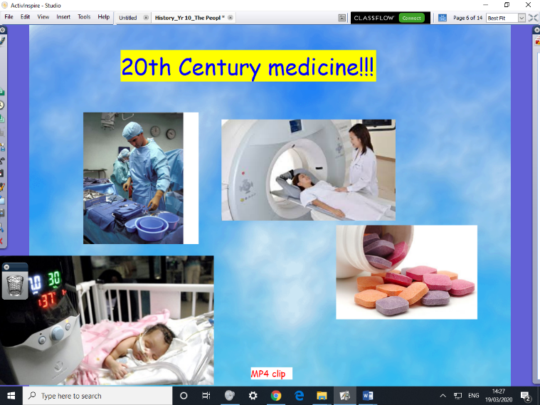
Hello again! Following on from last week’s work on 19th century Living Conditions, we are moving onto 20th century medicine this week.

This is a topic that could be too wide, for our students, so I usually use this video clip attached, to start a debate. I suggest you do the same at home.

Then, I propose we let the students explore that part of 20th century Medicine which interests them. Please see the other attachment for the topics they can choose from. Using their pencils and paper, what can they discover and note down about (1) one of the Blue ink and (2) one of the Red ink discoveries / new technologies - ??
Once again, please explore any areas of interest to your child using the web, as appropriate.

We would normally begin the end-of-unit assessment after this research project. We will have to see what is possible, this time around. More to follow, next week!

Best wishes! Mr Cartwright
23.3.20

