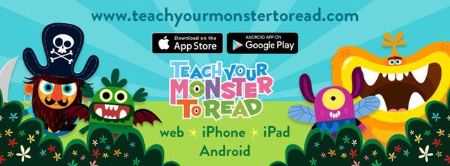

Dear Parents,

Teach your Monster to Read is an award-winning series of games which helps children to master the key first stages of reading. It's been created by the Usborne Foundation, led by Peter Usborne (of Usborne Publishing). We're using it at school and your child will benefit more from the game if they can play at home. It’s free to play on a PC and laptop, or you can download the Teach Your Monster to Read app from the app store on phones and tablets. To play on the website, visit teachyourmonstertoread.com and start playing in log-in using the following details- I will be notified of the progress that you are making each time that you play!

Mr Smith

Login details: Visit www.teachyourmonstertoread.com and set the ‘Star Code’ as 4214378
Username: Alfie Password: b0a6645
Username: Caelan Password: b6b616d
Username: Caspian Password: edb615j
Username: HarryF Password: 7ab615w
Username: HarryW Password: 8db615p
Username: Jasper Password: ecb6164
Username: Kareem Password: 8fb615a
Username: Lennon Password: 6bb61nj

