Name: Date:

Test Questions

- How much is each coin worth?
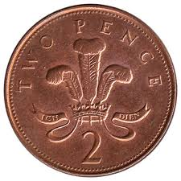
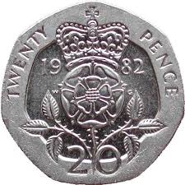

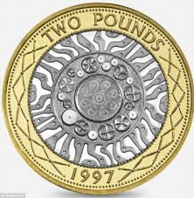

- How much is this worth?

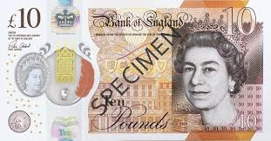

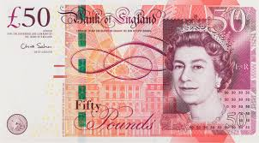

- Fred has these coins. How much does he have?
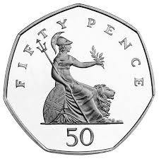
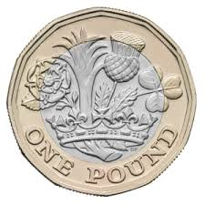
- Show two different ways you could make 19p with coins.
- Amy has 8p with four coins. The coins all have the same value. Which coins does she have?
- Jim pays exactly 11p with three coins. What are the coins?
- Write 347 pence in pounds.
£
- How many pence is £3.09?

- Simon has these coins.

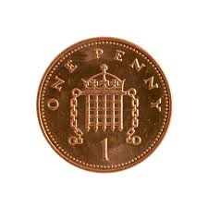
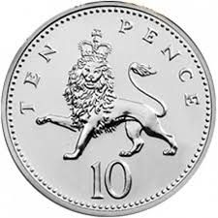
Does he have enough money to buy and Xbox game?
- Jane has £25 in notes. What notes could she have?
- Ollie buys 5 muffins for 31p each.
What is the total cost?
How much change should he get from a £2 coin?
- Rachel pays £1.35 for a drink. She has only 5p, 10p and 50p coins. Show two different ways she can pay.
13. James has these notes.
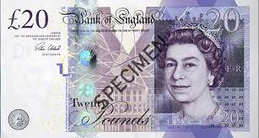
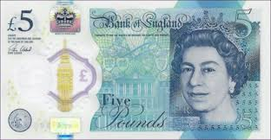
CD’s cost £13 each. James buys 7 CD’s. How much money does he have left?
- I have £10. Do I have enough to buy a pen?
- What is the total cost of 3 meals costing £14.50 each?
Highlight the correct way of writing the answer.
£43.50p £43.5 £43.50 43.50p
- How can you make £5 using six coins?
- Bill uses his calculator to add together £4.30, £2.90 and 30p. His calculator shows this answer. How much money is this?
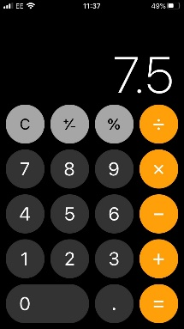
- Each month Tom earns the following money.
Washing up £14
Walk the dog £25
Help with shopping £15
Tom saves all of the money he ears. How many months will it take him to save £486?
- Sally buys three DVD’s for £15 each and a CD for £9.99. How much does she spend altogether?
She pays using these notes.
How much change would she get?
- Donald buys a drink and a packet of crisps for himself and 4 friends. Each drink costs 79p and the each packet of crisps costs 25p. How much does Donald spend?

