Sensory art and craft ideas

5 WAYS TO CREATE WITH PAINT
For children who dislike getting messy or avoid painting because of tactile defensiveness, try encouraging creativity by using household objects and toys in new ways - baking trays, straws, sponges, marbles, spice shakers, cotton buds- change up your painting tools for a different experience every time! Here are our favorite out-of-the-box ways to create with paint: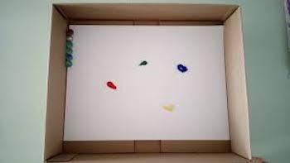
Marble Run Painting: Put blank paper into the lid of a box or baking tray, add a glob of your paint color (choose 1 at a time or add a few!) and a marble or two. Tilt the box/tray to move the marble through the paint and watch the kaleidoscope of colors emerge across the paper.
Cotton bud Details: Using a Q-tip to apply paint in controlled dots, lines, or squiggles is a great way to develop fine motor skills while also limiting the "mess." Depending on the level of creativity or independent drawing skills your child has, consider adding a background picture and use the cotton bud paint to add details to familiar shapes, landscapes, or people.
Paint in a Bag: Similarly to the sensory bag, children with significant tactile defensiveness are more apt to engage with this painting activity because the mess is all contained inside a Ziploc-type bag. Put a blank piece of paper inside of the bag, add a few drops of color, and zip the bag closed. By pushing on the outside of the bag, your child can move the paint around and explore with mixing colors to decorate a kaleidoscope on the canvas.
Stamping: Look around the house and see what you could use as a stamp - cut an apple or potato in half to stamp a unique shape, repurpose those Duplo Legos, or cut a kitchen sponge into shapes big and small.
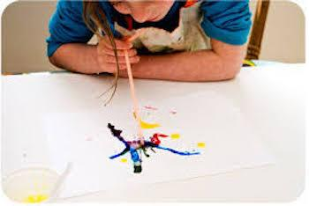
Blow-Paint: They actually sell blow paints for kids, but they require a lot of forceful breath that may be difficult for some kids to coordinate. Create your own "blow" paint activity by breathing through a straw to move the paint across the page. Can you blow the paint inside the shape of a balloon? To add colorful details to a picture already drawn? or to make your own free-form designs?
Beyond Paint
Your final product will surely look different, and you might have to wash away your art at the end of the activity, but the kids will get a kick out of creating with something other than paint. Who says that art has to happen on paper? Explore your washable surfaces or in the garden. Art is easy when you can wash away the mess!
- Shaving cream
- Corn flour and water
- Sand, water and washing up liquid

Sensory water bottles – Place water in a clean plastic bottle. Add glitter or small objects on the bottle. You can add food coloring to the water. Also works with sand and small objects.

