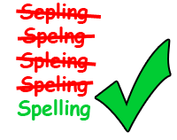
FS English E2+ Spelling Practise.
Spring 11
Week Beginning – 23/03/2020
Spellings | Monday | Tuesday | Wednesday | Thursday | Friday
circle
circulate
prove
disapprove
medic
medical
operate
operation
relate
relative

