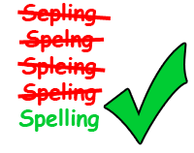
FS English E2+ Spelling Practise.
Spring 12
Week Beginning – 30/03/2020
Spellings | Monday | Tuesday | Wednesday | Thursday | Friday
care
careful
hope
hopeful
thank
thankful
use
useful
cheer
cheerful
beauty
beautiful
welcome
always

