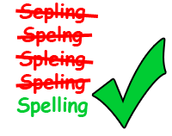
FS English E2+ Spelling Practise.
Spring 10
Week Beginning 16/03/2020
Spellings | Monday | Tuesday | Wednesday | Thursday | Friday
cover
uncover
act
actor
public
publicity
electric
electricity
light
lightening
examine
examination
assist
assistance

