Firebird
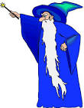
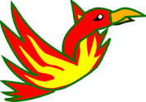
...based on a piece of music written by the composer Stravinsky.
1
The wizard casts a spell and turns people into stone. | The firebird flies in, they argue but in the end the firebird wins and the wizard’s wicked spell is broken. | The people celebrate by ringing church bells to tell everyone there is a party.  C C B A G F E D C
How will you make these sounds?________________________  Will you play quietly/loudly?________________________  Will you play fast or slow? ________________________ | How will you make the sounds of the Firebird? _________________________  _________________________ | What could you use to play a party tune?  _________________________

The wizard casts a spell

and turns people into stone.

- Make sounds for the wizard.

- Are they loud or quiet?

- What do you think about your wizard music?

