The Quick-Pour Soda Bottle Race
Create a vortex to drain a bottle of water in seconds!
Race to see who can be the first to empty a soda bottle full of water. With a special twist of the hand, you will be able to empty the water in the soda bottle in just a few seconds.

EXPERIMENt

1
Remove the label from the soda bottle so you have a clear view of the inside. Fill the soda bottle almost to the top with water.

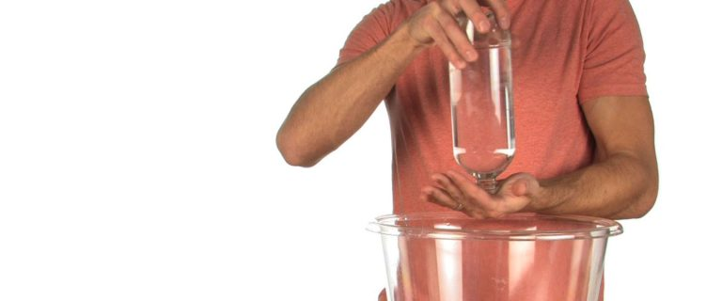

2
Without squeezing the sides of the bottle, turn it over and time how long it takes to empty all of the water. Just hold the bottle upside down. You might want to repeat this several times and average the results. Be sure to use the same amount of water for each trial. Now you’re collecting data!

3
Keep a table of the trials and call this the Glug-Glug Method.
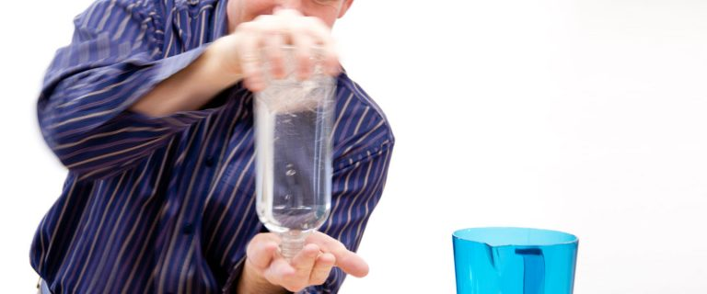

4
Refill the bottle almost to the top with the same amount of water as you did before. When you turn it over this time, move the bottle in a tight, clockwise or counterclockwise circular motion as the water pours out.

5
Keep moving the bottle like this until you see the formation of what looks like a tornado in the bottle. The water begins to swirl, a vortex forms, and water flows out of the bottle very quickly.

6
Time this method as you did before and call it the Vortex Method. Repeat the test several times and average the results. Which method allows the water to exit the bottle more quickly?

HOW DOES IT WORK
“Auntie Em, Auntie Em, it’s a twister!” Well, it’s sort of a twister. If you’ve ever seen a dust devil on a windy day or watched the water drain from the bathtub, you’ve seen a vortex. A vortex is a type of motion that causes liquids and gases (both are fluids) to travel in spirals around a centerline. A vortex is created when a rotating liquid falls through an opening. Gravity is the force that pulls the liquid into the hole, and the rotation causes a continuous vortex to develop.
Swirling the water in the bottle while pouring it out causes the formation of a vortex that looks like a tornado in the bottle. The formation of the vortex makes it easier for air to come into the bottle and allows the water to pour out faster. If you look carefully, you will be able to see the hole in the middle of the vortex that allows the air to come up inside the bottle. If you do not swirl the water but just allow it to flow out on its own, then the air and water have to take turns passing through the mouth of the bottle (thus the glug-glug sound).

TAKE IT FURTHER
See if you can figure out new methods for getting the water out quickly. Time your trials and record them. Get another bottle and challenge your friends to a race. Until they learn the secret, you will win every time.
For a giant tornado, try filling a Deep Rock brand water bottle to the top with water, swirl it quickly in a clockwise or counterclockwise circular motion, and watch the powerful vortex form. Okay, this method is going to take a very strong person to swirl the water . . . and it’s going to make a huge mess. Just take it outdoors and enjoy watching the strong person’s shoes get drenched!
If you want to create the tornado over and over without having it drain down the sink, try a popular science toy called the Tornado Tube® (available on in our product store). The Tornado Tube connects two plastic soda bottles together and allows for the water to move from one bottle to the other as the bottles are tipped. Start with all the liquid in one bottle, quickly tip the bottle upside down, and start the swirling motion. The tornado (it’s actually a vortex) will form as the liquid moves into the bottom bottle.
If you want the tornado to be more visible, squirt a few drops (no more) of liquid soap into a bottle of water. Connect the bottle to an empty bottle using the Tornado Tube, shake the bottles to make some suds, and swirl the liquid quickly in a circular motion. Look for the vortex in the middle of the bottle. The drops of soap help make it more visible.
Sure, anyone can color the water by adding a few drops of food coloring. Here’s a real challenge: how would you go about coloring just the swirling vortex while keeping the surrounding water colorless? I struggled with this self-imposed challenge for months. My initial thought was to try adding a small amount of oil to the water. Of course, it’s next to impossible to add coloring to oil, and the thickness (or viscosity) of ordinary vegetable oil destroyed the formation of any kind of vortex.
Then I stumbled upon a kind of colored oil at the local hardware store. It’s called lamp oil, and it’s used in outdoor lanterns or indoor oil lamps. Best of all, lamp oil comes in an assortment of colors. Purchase your favorite color of lamp oil (the red oil makes a really cool colored vortex) and try adding 2 ounces of the oil to the water in the soda bottle. Use the Tornado Tube to connect the two soda bottles and swirl the water using your now famous vortex-forming, swirl-of-the-bottle technique. When the oil and water swirl together, the less dense oil travels down the vortex first and creates a colored tornado effect. Remember, oil and water do not mix because oil is hydrophobic (water-fearing). The two liquids are said to be immiscible, which means oil and water cannot be mixed or blended. Since the oil is less dense than the water is, it forms a layer that floats on the surface of the water.
As long as you’re adding things to the water, go on a scavenger hunt for a few miniature plastic houses from an old Monopoly game, plastic barnyard animals, glitter, beads, and anything else you can think of. Place the items in an empty bottle and fill the bottle three-fourths full of water. Attach the Tornado Tube and the second bottle. Swirl the liquid to create the vortex and watch what happens to the items you put in the bottle. Where were the items before you swirled and where did they go once the tornado formed? Toto, we’re not in Kansas anymore!

