Year 10 History: The Rise of the Nazis

Watch the cartoon video on the Nazis rise to power:
https://www.bbc.co.uk/bitesize/guides/zpknb9q/revision/6

and the clips available at:
https://www.bbc.co.uk/bitesize/guides/zpknb9q/revision/2
https://www.bbc.co.uk/bitesize/guides/zpknb9q/revision/3

Why did Hitler come to power?
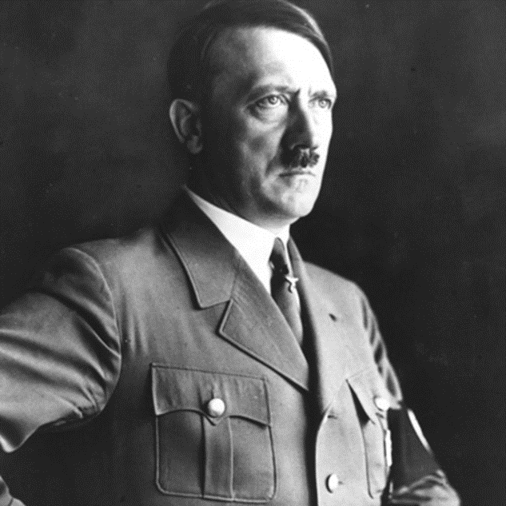
You may choose to present your work through a spider diagram/ mind map, a poster or a PowerPoint presentation.

