Research Project

World War One Timeline of Events
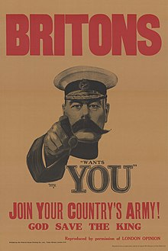
Below is a list of significant events that took place during WW1 in the wrong order.
- Find out when each event happened
- Write one sentence about its significance
- Find a picture to go with it
- Put the events into a timeline

- Germany invaded Belgium
- First tanks in WW1
- German gas attack at Ypres
- USA joins WW1
- Armistice Day
- Assassination of Archduke Franz Ferdinand
- Conscription introduced in Britain

Use Powerpoint
Save your work
Print your work
Give a copy to Miss Baker

