Name:

Date:

A chat between a mouse and an elephant.



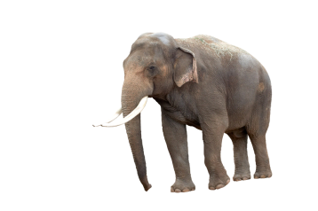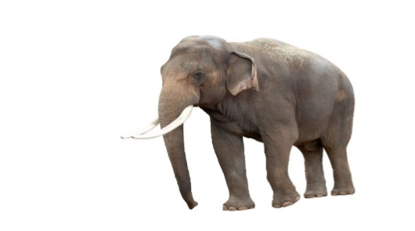

O I can play my mouse or elephant sounds.

O The elephant is playing _ _ _ _ sounds.

Name:

Date:

Elephant beats

1. Clap the sentences. How many claps?
2. Draw a circle for each clap.
3. Now make up your own elephant beat.

Elephants are huge. ______________________

Long swinging trunk. ______________________

O I can play my elephants beats.

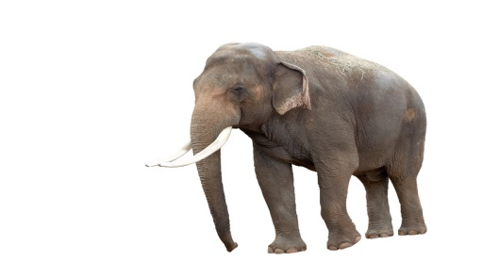Name: Date:

Elephant

Use the notes: c d e f

Make a long sound for the elephant’s long _ _ _ _ _ .

Play each note and count up to 10.

O I can play my long sounds on the _____________________.

Name: Mouse sounds Date:

Use the notes :

a b d g

Can you play these notes fast and short?

O I can play my mice notes fast and short.