Online reading and writing activities
bbcbitesize
https://www.bbc.co.uk/bitesize/subjects/zv48q6f

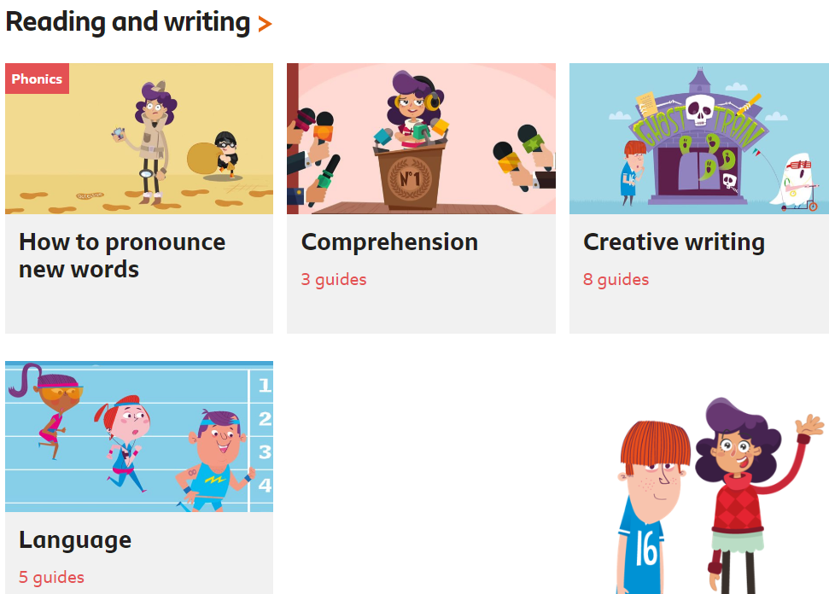

Language includes features of poetry we have looked at in class:

