**singer**

**drummer**

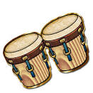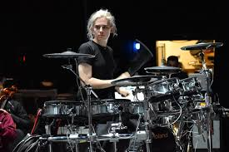

**guitarist**

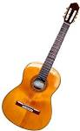

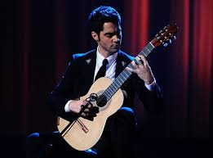

**xylophone player (percussionist)**

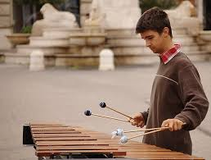

**pianist**





1. **Find a famous person for each of the musicians.**
2. **Find out about how they became famous, which country they live. What style of music they are famous for and what skills they have.**
3. **Put the information you have found in a poster or powerpoint.**