Strategies for Reading Unfamiliar Words

When you come across a word you don’t know, use these strategies to help you read it!

Sound out the word  Always try this first! | Look for smaller words within words  outside  out/side
Break words into syllables  e.g. cat-er-piller | Use the pictures
Skip the word and read the rest of the sentence to try and work out what it says | Did the sentence you read make sense?

Week 1: Tuesday: Word Reading 1

What do blue whales look like?

The blue whale is big.

They are the biggest animals that have ever lived!

Blue whales can grow to over 30 metres long and are heavier than 25 elephants.

They have a dark blue skin. The skin is smooth and slippery.

Blue whales have two small round eyes on the sides of their head. They are as big as a cup and very black.

They have two very tiny ears on either side of their head. Blue whales do not have ears that stick out, instead they are just small holes.

On the top of their head they have two large nostrils. They come up to the surface of the ocean to breath.
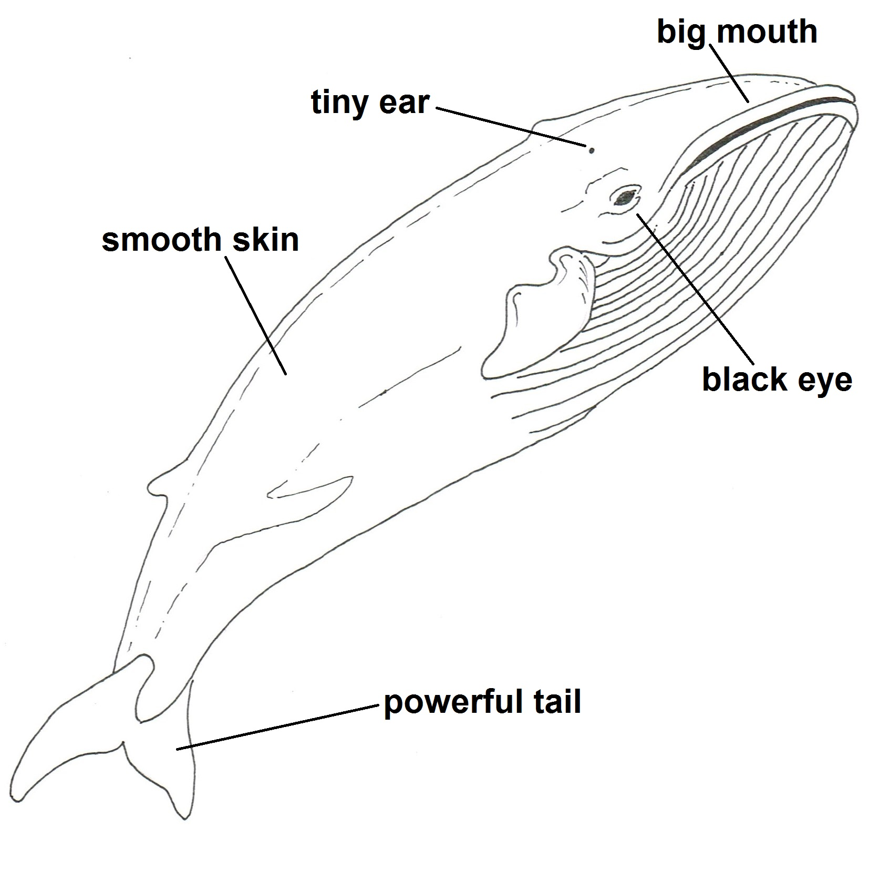

An adult blue whale is bigger than the biggest dinosaur.

Week 1: Tuesday: Word Reading 1

What do blue whales eat?

The blue whale doesn’t eat people. It doesn’t have any teeth.

Instead, hanging from its upper jaw are long horny plates, fringed with course hairs. This is called baleen.

Blue whales eat tiny shrimps, called krill. They are the same size as your little finger.

It takes in a huge mouthful of seawater, filling its throat. Then it shuts its jaw and uses its tongue (which is as big an elephant) to push the water between its bristly baleen plates.

The krill stick to the baleen plates and it then uses its tongue to lick them off and swallow them.

It spends all summer eating krill and getting fat.
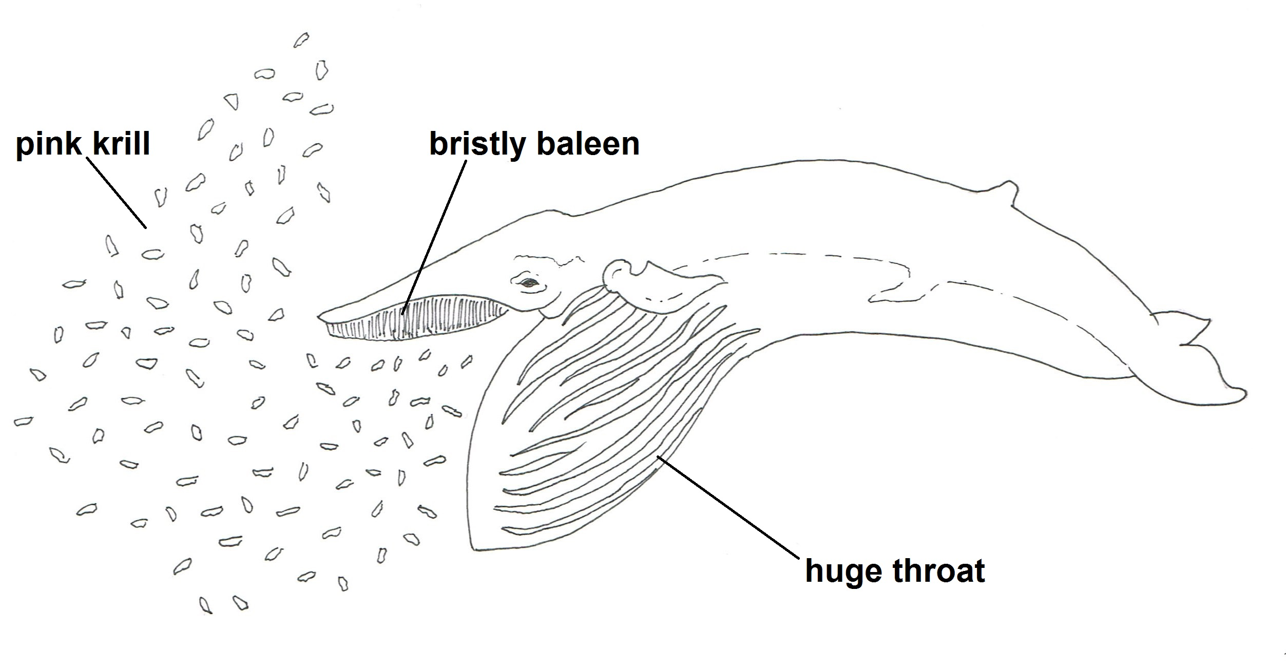
The throat unfolds and opens out.

Week 1: Tuesday: Word Reading 1

Where does the blue whale live?

In the summer blue whales live in the icy waters around the North Pole and South Pole. This is where their food, krill, lives. Sometimes there is so much krill in the water, the water turns pink.

In the autumn the water begins to freeze and turn to ice. The krill hide under the ice where the whale cannot catch them. So the whale swims to warmer water.

It takes about two months for the whale to travel from the cold polar water to warmer waters around the equator. This is where they spend the winter.

It is here that the mummy whale gives birth to her calf, where storms and cold weather can’t hurt it.
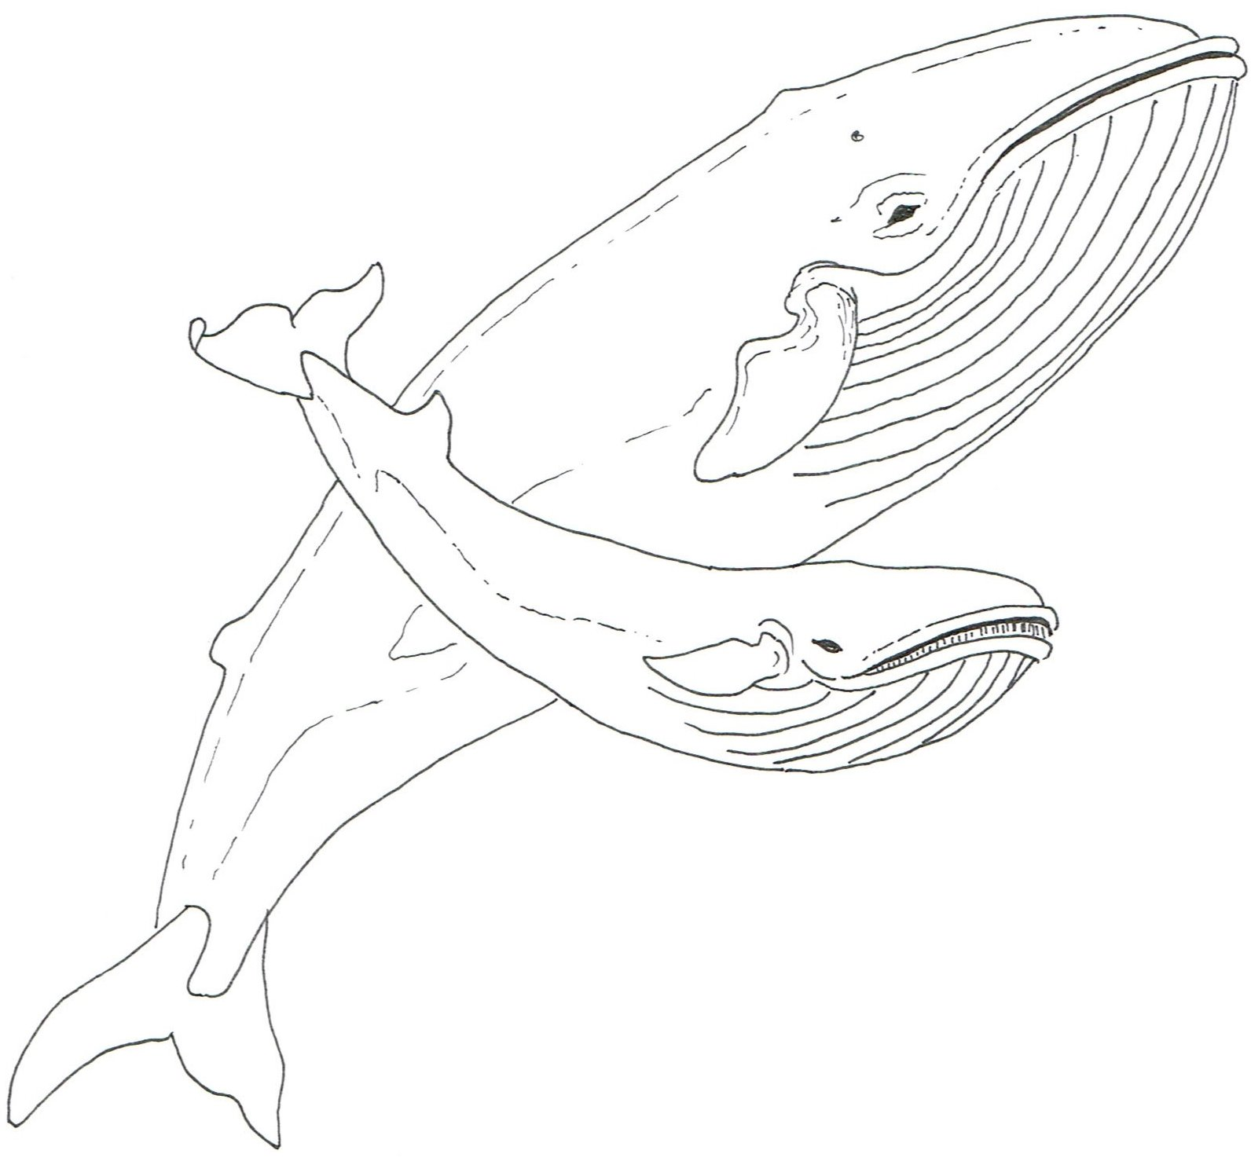
A whale calf is born in the warm water near the equator.

Week 1: Tuesday: Word Reading 1
Tell Me More About Blue Whales

Remember: If you are not sure of an answer to any question, look again at the information!

How long is a blue whale?
Why are they called blue whales?
Can you describe the skin of a blue whale?
How many nostrils do blue whales have?
Why do they need nostrils?
What other animals breathe air?
Will a blue whale eat you?
What does a blue whale eat?
Can you describe baleen?
What does a blue whale do in the summer?
Why do blue whales swim to the water around the equator?
How long does it take a blue whale to swim to the equator?

Week 1: Tuesday: Word Reading 1

The Blue Whale
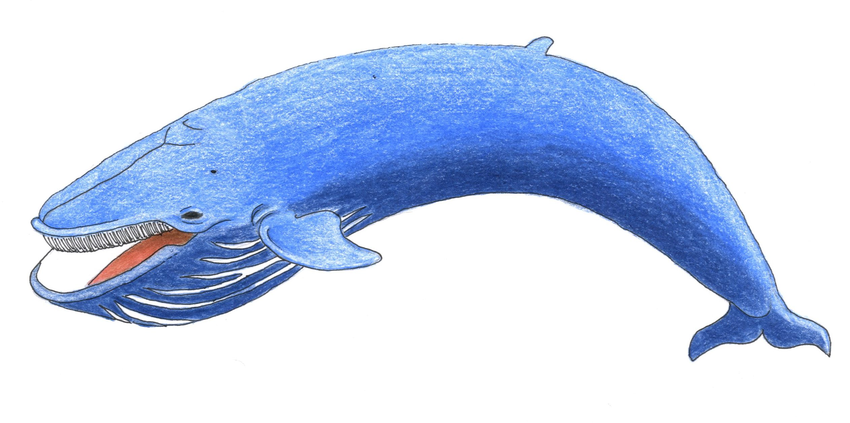
Blue whales breathe air.
- Draw a detailed picture of a blue whale.
- Colour your drawing carefully.
- Think of a sentence to give extra information about your drawing.
- Write your sentence under the picture.
Week 1: Wednesday: Grammar 2

The Blue Whale
- Draw a detailed picture of a blue whale.
- Colour your drawing carefully.
- Think of a sentence to give extra information about your drawing.
- Write your sentence under the picture.

Week 1: Wednesday: Grammar 2

Whale Words
- Read each label.
- Cut out the labels you can use for your illustration.
- Place them next to the parts of your blue whale.
- Draw a straight arrow between the label and the part of the body.

EASY/INPUT
tail | eye | ear
throat | skin | mouth
nostril | tongue | fin

MEDIUM
tail | eye | ear
throat | skin | mouth
nostril | tongue | fin
belly | notch | baleen
fluke | jaw

HARD
Week 1: Thursday: Transcription 1
Non-fiction Vocabulary

- Cut out each label or copy these onto small sticky notes.
- Check the chn can read them fluently.
- Give each child a non-fiction book.
- Locate each feature and place the label next to it

Ensure the adult selects a good example of a non-fiction book that clearly has all of the features noted below. They will use this to model each feature to the group, before the children use their own text to find the corresponding feature. The teacher may like to limit the number of labels depending on the ability group they are working with.

contents | front cover | glossary | heading
page number | illustration | label | caption
back cover | title | blurb | fact

Week 1: Friday: Comprehension 1 (Activity number 4 on carousel)
Fiction or Non-fiction Books

Write the titles of the fiction books

Write the titles of the non-fiction books

Week 1: Friday: Comprehension 1 (Activity number 3 on carousel)

[heading]
[illustration]
[caption]
[facts]
[page number]
[facts]
[facts]
Week 2: Tuesday: Composition 1

Week 2: Tuesday: Composition 1

How to Make a Perfect Page

To make your page perfect:

- Say each sentence aloud before you write it.

- Neat handwriting.

- Read each sentence again to check it makes sense.

- Careful colouring.

- Ask for help if you need it.

Week 2: Tuesday: Composition 1
Non-fiction Features

Today, your group will publish its own non-fiction book.

- Cut out each word.
- Read them.
- Match the word to the pages of your book.

What features are missing from your book?

front cover | contents | glossary | headings
page numbers | illustrations | labels | captions
back cover | title | facts | blurb

Week 2: Thursday: Comprehension 3

Week 2: Thursday: Comprehension 3

We are presenting our own information books!

Please come and find out about blue whales… in the most entertaining way possible!

Date: _________________________

Time: _________________________

Place: _________________________

Blue Whales are fascinating. Let us astound you with all of the fantastic facts we have learnt.

Love from ______________________

Perfect Presentations

When you present information to an audience you must:

- Use a louder voice, so they can hear you.

- Be engaging, so people are interested in your voice.

- Speak clearly, so they don’t get confused by what you say.

- Look at their face and into their eyes, so they will believe the information you are telling them.

Week 2: Friday: Spoken Language 2

Positive Feedback

- Listen to our performance.
- Tell us everything you thought that was good about it!
- Write two sentences to tell us what you really liked, and one sentence with some advice about what we can do differently next time.

We practised:
- Speaking clearly
- Speaking loudly
- Speaking confidently
- Looking at the faces of our audience
Next time think about

We really like

We really like

Week 2: Friday: Spoken Language 2

