Remote Learning Art Challenge
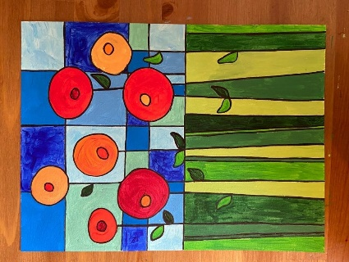

Poppies are very brightly colored flowers that bloom in early spring and come back year after year. They have wide, flat petals that lie in a near circle, and have black or very dark centers.

1: draw an odd number of larger circles, each with smaller circles in the centers
2. Use a ruler to draw one stem from each poppy,
3.then add one or two leaves per stem.
4.Use your ruler to add vertical lines for grass and horizontal lines for the sky.

5.. Add color with crayon, coloured pencil, watercolor, oil pastels, felt tips or poster paint.

