Name: __________________________________________ Date: ________________

**LO: I can solve X word problems**

1. Joe makes 5 trays of cakes. There are 5 cakes on each tray. How many cakes did he make altogether?

2. 7 children are at a party. They each eat 2 cakes. How many cakes are eaten altogether?

C:\Users\Claire\AppData\Local\Microsoft\Windows\Temporary Internet Files\Content.IE5\KOMNUVQJ\MC900436682[1].wmf

3. One spider has 8 legs. How many legs will 2 spiders have?

4. There are 7 days in one week. How many days are there in 5 weeks?

5. There are 10 sweets in a packet. How many sweets will be in 2 packets?

6. There are 4 wheels on one car. How many wheels will there be on 5 cars?

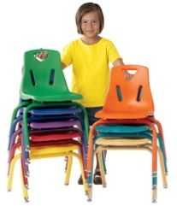7. Chairs get stacked in piles of 5. There are 10 stacks of chairs. How many chairs are there in total?

8. Tom gets £6 a week pocket money. How much will he get in 10 weeks?



9. For a children’s party, the teacher buys multipacks of Hula Hoops. There are 6 in each multipack. How many in 5 multipacks?

10. Twix come in packs of 2 fingers. How many fingers will there be in 7 packs?