Year 11 Art students should continue with their suggested activities in the sketch book provided.
If these have all been completed then using the drawing online tutorials on the Art activity grid will be useful.
You could also plan out your final piece for your exam. Below are the ideas spoken about in class for each theme. You should know your theme and could possibly try out some of the techniques at home with some help. I understand you may not have access to the materials and in this case sketches of ideas for your final piece would also be useful.

Exam title | Artists | Development and Possible exam outcome | Activity plan
Rainbows | Jen Stark  Dan Russo  Poss Olafur Eliasson | Bubble photos and observational drawing.  Colour theory discs / light ( olar Elaisson)  Rainbow patterns / prints over animal portaits (Dan Russo)  Rainbow drip pictures (Jen stark) turn into wool painting or paper sculpture. | Create drip patterns with paper, paint and wool (stick wool to sticky back plastic.  Use drip pattern for back ground of canvas.  Separate paper Dan Russo inspired pet portrait. – experiment with busho on filter paper or material?. Trace over image of pet. Use stencils (paper stamp cutters from card) to paint on extra acrylic details. Use black wool as outline?  Stick to canvas and add drip pattern background. 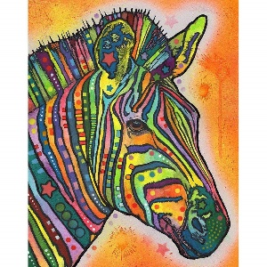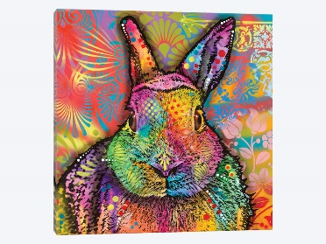
Dance | Edgar Degas – movement and poses of ballerinas. Relate to own dance interest.  Tim wakefield – soundwaves art. | Use of wooden figure for observational drawings  Perspective drawing of dancing silhouettes.  Flipbook  zoetrope  art from soundwaves | Observational drawing of wood figures in same position as photos taken in abbey gardens.  Create soundwave pict in diff ways – strips of paper, fan brush. Painted card.  Cut stencils on 3 or 4 dance position shiloutes (using observational drawings  Cut strips of card diff lengths and arrange as a sound wave. Paint. Stencil on dancers  Attach card strips to wooden pole or frame with nylon string.  Research soundwave art.
Shape | Victor Vaserely | Japanese notans
Transform | Juan Fontanive  – flipbook artist (see colossal also hole punch flip book Scott Blake)  M C Escher – Transformation prints.  Mathethmatical (like DNA)  Impossible constructions – buildings.e | Transformation paintings  Photography buildings through ages  Mono or linoprint buildings  Multipoint perspective pictures of buildings transforming.  a flip book.  Zoetrope | photos of abbey ruins. Photo of abbey gate.  Make simple flick book of building falling down.  Use abbey gate photo to make lino cut. Print several images. Then cut pieces away to signify destruction … take prints … cut more pieces away .. take prints … until left with something that looks like ruins .. take more prints.  Shrink these prints on PC and make in to flick book. Also present as a linear landscape picture.  Or  look at section of Eschers transformation picture. Try to replicate using cut squares and drawing details on then cutting out. Try own but starting with own shape square – to monkey – more detail, to man? Cut out and arrange in a flick book.  Research zoetrope and make.  Shrink pictures if needed and arrange in Zoetrope.  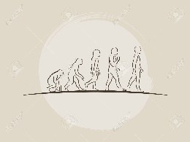  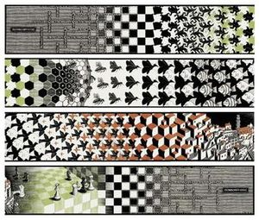  Metamorphis.  encounter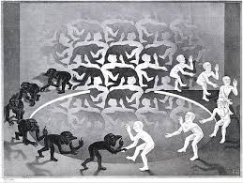  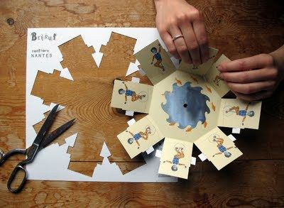
Event | Peter Callesen (paper cut artist)  Michael Irvine – automotive artist. | Observational perspective drawing  Car part drawing (homework)  Photos zooming in on one element | Make paper cut outs of different angles of cars.  Design model car and work out build. Leave car shape cut out of car for the base of model.  Try out different body work paint colours.
Sport |  |  | Wire motor cross sculptures against white card. Continuous line drawings of helmet, bike, wheels. Present on white card. Research the wire sculpture artist.

