Making a human body with food
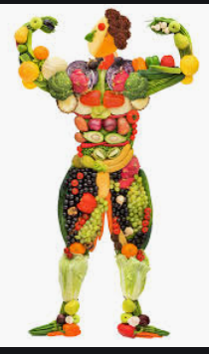

Can you design a human body with different types of foods? Take a picture and share it with your teachers

Here are some ideas:
Carrots for eyes

Celery as bones

Tomato for the heart

Mushrooms for ears

